|  |
| --- |
| Temperature Monitoring System |
| Chamith Kotage |

Analysis

**Problem Identification**2

Problem Description2

Proposed Solution2

**Stakeholders**5

Stakeholder Interviews5

Stakeholder Requirements6

**Research**7

Similar Existing Solutions7

**Success Criteria**9

Design

**GUI design**11

**Usability Features**15

**Modular Design**17

**Top down Design**18

**Algorithms**20

**Inputs/Outputs**24

**Data Structures**25

**Validation and Verification**26

**Testing method/Test plan**26

Development

**Testing**

**Stakeholder Review**

Evaluation

**Testing**

**Stakeholder Review**

## Analysis

# Problem Description

After volunteering at a Cloth Manufacturing Company (SewPort) I quickly realised that a common problem among many factory workers is that they struggles to cope with extreme temperatures that arise due to large operating machinery in the work floor even though there seems to be a fan system set in place it is currently not functional so the temperatures in the building can vary quite considerably throughout the day. Heat is therefore one of the biggest causes of complaint from workers. If the temperature rises too high, then it can become a health and safety issue. Even at lower temperatures heat leads to a loss of concentration and increased tiredness, which means that the workers are unlikely to focus.

After experiencing this struggle myself I was inspired to come up with a solution, I realised that some system must be put in order to monitor and control these temperatures some way. If this can be made possible I trust that the workers can work comfortably and efficiently. At the moment the SewPort does not have a mechanism in place to handle this issue. If in some way a system was to be produced and then I am certain that it will have a number of befits for both workers and the company itself. Majority of work floors use appliances such as fans but only a very few (usually high budget) work floors contain sensor based hardware to monitor temperatures. It is arguable that in general low budget companies and companies with elderly workers with lacking technological experience tend to have low computational expertise to handle an approach such as this. However I aim to make my program simple to understand so intensive training would not be required to operate it.

# Proposed Solution

My proposed solution is a simple temperature control system that will essentially model what is required of a larger system. I believe that when my model is applied to a system it could to save energy and money by automatically maintaining different temperatures at different times of the day and night. It will essentially be used to model a feedback system having a control loop, including sensors and control algorithms, and will be arranged in such a fashion to try to regulate a variable at a set point or reference value. In order to accomplish this I must be able to read outside temperature and be able to process this data so I will need some form of a hardware sensor to obtain the temperature and humidity and software capable of reading the hardware data and processing this. A Computer with the necessary software and hardware capability to obtain real time temperature and humidity readings would be required.

In simples terms the, the solution would receive the temperature and humidity readings via a hardware sensor and software will then be used to process the received data and plot a graph (to show trends in temperature and humidity) and warn the user if the temperature reaches extreme values.

So in summary my program aims to resolve the problem that high temperatures can have on factory workers. My proposed program involves the design of a software program that will operate from the technician’s office located next to the work floor. The application will contain a GUI control panel for the connected hardware (Sensor and Light).The sensor and hardware will be located in the work floor and linked to the office computer via a USB cable. The program will allow the management to set warning value for temperature. The application will display live temperature and humidity in the workshop monitored via the sensor. The program will present these values in the GUI and then automatically instruct the user to turn on the fan or Trigger a warning light if the temperature goes above and below the set temperature value.

# Need for Computation

This problem requires a computational approach because it requires data to be input, processed and output and this is the general function that defines all model computer systems. In order to receive live temperature and humidity readings, necessary software should be installed and the operating system must be capable of running the program. Another reason this problem requires a computation is that it requires the user to interact with a computer. I personally believe that using a computational approach is far more advantageous in comparison to a mechanical or electrical approach to solve this problem because computers are far more efficient in terms of their fast calculation speed, multiple forms of input and output devices, large memory, programmable control, small and light in size and also due to its Possibility of telecommunication.

Furthermore computational methods allows me to break the problem down into smaller sections so that

* Simulations can be run-So it can run the program to check that the graph is plotted using live readings.
* Variables can be used to represent data items –So that I can assign the values of temperature and humidity into values that can be used within the program.
* Algorithms can be devised to test possible situations under different circumstances – So that I can create algorithms to test whether or not set temperatures has been exceeded.
* Logical reasoning can be used – So that decisions can be made when live temperature exceeds the set temperature to let the user know to turn the fan on and warn the user visually.

I will explain the types of computational methods I will be using in my program and why I will require them.

Divide and Conquer: When a task is split into smaller tasks that are then tackled. I will be using this when plotting the live chart for temperature and humidity because in order to do this I will first need to receive live readings and in order to do this I will need to connect the sensors and program them and etc.

Visualisation: When a computer process presents data in an easy to understand way for humans will be using this because my program will include a live chart which will be used to aid in visualisation and will be used to show trends of temperature and humidity.

Please Note added this recently since I did not initially plan to include the login form in my program.

Backtracking: A strategy for mobbing systematically towards a solution. It Looks back at a progression through the stages of solving a problem and if the pathway fails it goes back to the last successful stage. In the login form if the input received is invalid then it will backtrack to the pervious stage and ask for input again.

# Stakeholder Identification

My stakeholders are two people I’ve worked with during the time I’ve volunteered at a manufacturing branch at SewPort. I will be emailing them to receive feedback during the development of my program. This will allow the application to be tailored according to their needs. The two stakeholders that I have chosen vary greatly in terms of experience of using software and technological experience in general, therefore by picking them allows me to test my program on users with varying computational experience.

The clients who will be testing the software is as follows

* Mr Grey - Work floor technician, aged 42(High experience with Computation)
* Mr Kumarswarmy – Factory Worker, aged 65(Low experience with Computation)

# How does the solution affect the stakeholders?

I believe that both of my stakeholders can benefit from my system because it is aimed to solve a problem that they commonly struggle with. Mr Kumarswarmy have low experience with using computer systems so I believe that he can benefit from the solution because it will give him the chance to test the software and gain experience from using a computational approach to deal with a problem. Mr Gray has high experience with using computer systems in comparison to My Kumarswarmy and I believe that the system will give him the chance to test his programming skills and gain experience.

# Stakeholder Interviews

I have listed below some of the major questions I asked during the interview. The questions are mainly based on the software and the user’s requirements. The interviews are sorted from ascending experience with computer systems.

Mr Kumarswarmy (No experience)-Factory Worker

1. **Are you at all affected by temperature of the work floor?**

“Yes it gets too hot in the workplace because of large machinery. It is hard to concentrate and I get tired easily”. Even though I have not been seriously affected, over the years we had people having migraines and once we had a worker fainting!”

**2. If so what measures has been taken so far to control the temperature of the work floor?**

The uniform was changed so the staff can wear short sleeve instead of long sleeve.

**3. Do you have any suggestions for my system?**

Yes please suggest you make the system easy to understand and navigate to those who are less experienced in using technology Such as Myself. Might I also request that you offer instructions on how to navigate the website?

4.Do you know when the fan systems will be repaired? They were supposed to be repaired a few months ago but that still have not been done. Even if they are repaired only the management can access them if the temperature gets high enough.

I believe that Mr Kumarswarmy’s input is crucial because to my knowledge most workers are like him and lacks experience in using computational methods to solve problems therefore I can get a rough estimate of what is needed from users with less experience. If I focused only on people that have experience I will be exclude crucial feedback.

Mr Gray – Work floor Technician (High Experience)

1. **What types of software are you comfortable with using?** “I am comfortable with using use word processors, accounting software like QuickBooks and some application software as well.”

**2. Do you think that a computerised system is suitable for this problem? “**Absolutely because computer systems are able to react to real time data without having to worry about human error.”

**3. I am thinking about using Visual Studio and Arduino. Do you think this is suitable?** “Personally I have not visual studio in a long time but from what I can recall it is great for application development and since this is going to be an application I would say it’s suitable but please research more my knowledge about visual studio is very limited. I have never used Arduino so again do whatever is suitable and cost efficient.”

**4. Do you think the workers would benefit from a temperature control system? “**Yes. Definitely but I am not sure that our budget can handle because of its the large expense, and the nature of the building. Whilst the ideal solution is to install air conditioning throughout, this was ruled out because the price was too high.”

Mr Gray’s input gives me a technical viewpoint of considering the problem and given his experience with using application software means that I can require feedback regarding functionality of the program and the user interface.

# Stakeholder Requirements

So concluding the feedback I received from the interviewers I asked them to create a specification, Mr Kumarswarmy was reluctant but Mr Gray summarised the following points and formed the following the Success Criteria according to it the system must:

* Receive Real Time Temperature and Humidity Values via sensor and allow the user to view them
* Allow the user to set a value to determine Fan Output, if live temperature exceeds this value let the user know the fan should be on.
* Allow the user to a set value to determine the output of a warning light, if live temperature exceeds this value then trigger the warning light.
* Display a warning to alert the user when temperature reaches a critical value.
* Make sure the design is user friendly, simple and have large enough text for users with weak eyesight.
* Offer the user help with navigating the system.
* Produce a Live chart showing live temperature and humidity readings.

# Researching the Problem

Existing Similar Solutions – These are some of the existing solutions which resemble somewhat closely to what I aim to produce.

**TH140 Temperature/Humidity Sensor**

[](https://www.google.com/url?sa=i&rct=j&q=&esrc=s&source=images&cd=&cad=rja&uact=8&ved=2ahUKEwjJnKDx5IjhAhVCWBoKHa8GDUUQjRx6BAgBEAU&url=https://rletech.com/our-products/facility-monitoring-systems/wired-sensors/th140/&psig=AOvVaw1glDZWENZ6fJJP866HI5Nd&ust=1552898774644753)

This Sensor is a wall mounted sensor that can monitor temperature and humidity values from an environment and consists of a handy application which allows the values to be viewed via a smartphone or tablet.

The fact that this system monitors outside readings and allows the user to view them is the similarity that is shared between my program. However I wish to take this step further by introducing the warning system, also my system will have more emphasis of software rather than hardware. The feature to allow the readings to be accessed on a phone or a table is a very convenient feature however if I used in my solution I would be making the system more complicated which is a factor that I must consider.

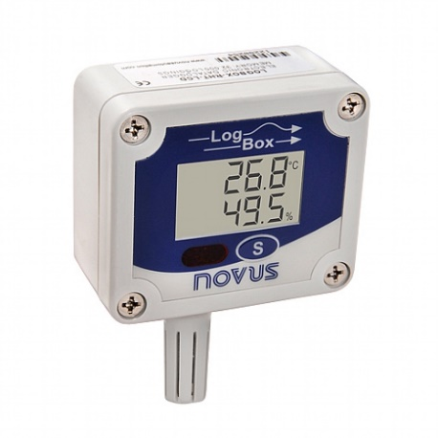**LogBox Temperature & Humidity Data Logger**

This is a data logger from Novus automation (<https://www.novusautomation.com/>) .It monitors and displays temperature and humidity values in an LCD display. Data can be configured and retrieved from Windows software Xp up to 7 where the data can then be exported to an excel spreadsheet. High quality industrial grade humidity sensor for accurate and reliable operation in applications such as transportation, food and goods storage, process auditing, pharmaceutical, HVAC and others

The fact that the data can be exported to an excel spreadsheet can prove quite useful however it can only export data into operating systems up to windows 7 only, this is inconvenient because the users with Mac Os systems will not be able to extract data into their machines, also most systems in the present day use windows 8 or higher. My system will be able to run in any operating system. Furthermore this can prove troublesome to those who are less experienced with computational methods.

**La Crosse Alerts Mobile 926-25101 GP Wireless Monitor System**

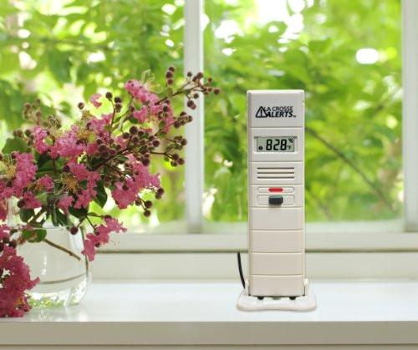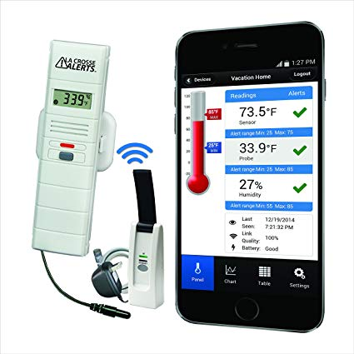

This is a remote temperature monitoring and control system by La Crosse Technology. The system is able to remotely monitor temperature and humidity. The system allows the user to set values and trigger warnings according to those values. Furthermore system has a very useful feature where it can send the user an early warning message if their set values are exceeded by live values in order to do this the users are required to create and account at their website(<http://lacrossealertsmobile.com/> ) and download their free app on their mobile device. However according to customer reviews it has been shown that the app can sometimes be buggy. The users are also required to connect a gateway to their internet router.

The feature where the users are able to set warning values will be used in my program to ensure that the users are warned if temperatures of the work floor reach extreme values. The mobile application feature is very useful however the stakeholders requested the program to be simple and added feature of the application may increase the complexity of the program for users with less experience using computational approaches to problem solving.

Features and Limitations of the proposed Solution:

My solution will be a live temperature and humidity monitoring system. When started the users will be able to view live readings for temperature and humidity and It will consist of a warning Light built into the hardware to warn the user if temperature reaches a very high values. The system will also consist of a graphical chart showing trends in temperature and humidity.Even though the user can be warned if the temperatures reach extremely high values, the system will not be able to control the temperatures. This will be very difficult to implement due to the lack of hardware to do so and also due to the limited time frame.

# Requirements and Success Criteria

In order to design my program and meet my requirements I will require both software and hardware.

Software:

* Visual Studio 2015: I will use this in order to develop and run my program.

Hardware:

* I will be using an Arduino Uno in order to receive readings and as a warning system to the user, not to mention that I will also require the use of basic peripherals such as keyboards and mouse’s to develop and run the program.
* DHT11 Sensor – I will be using this in order to receive live readings for temperature and humidity.
* LED – I will use this in order to Warn the user of

SMART TARGETS

* The application should display real-time temperature and humidity readings from the workshop floor. The program will be able to read serial data from the sensor for temperature and humidity values
* The program should allow temperature to be set to compare with the live reading.
* The program should be able to Switch On and Off the fan when temperature is above the set temperature
* The program should alert the user either visually just in case the fan fails and temperature reaches critically high.
* A graphical chart of the temperatures and humidity should be plotted to show trends.
* The program should display help so the user knows how to navigate and interact with the interface.

## Design

I Will use Visual Studio in order to design my program (although some programming will be done with Arduino the user will not see it). Visual studio is essentially an IDE which is great for creating great for devices or desktop apps, for the web and in the cloud. Write code for iOS, Android, and Windows in one IDE. It allows easy code navigation, fast builds, and quick deployment.I believe that Visual Studio will increase my programs productivity and make it easier to run my simulations. Visual Studio Code features a high speed source code editor, perfect for day-to-day use.

The programming language I have decided to use is Visual Basic, mainly because I have used Visual Basic before and I find that Visual Basic is easy to understand in comparison to most other Programming Languages also Visual Basic is good for Application Development. Furthermore Visual Basic is very Popular so if I require assistant or need help with programming there are many resources such as websites and support groups are available online. Main advantage of Visual Basic Compared to all the other languages is the fact that Visual Basic has the widest variety of tools available that I can download on the internet and use in my program if needed.

My program will essentially consist of three Forms.

According to my specification requirements that I made from my interviews, now will list my design objectives.

Design Goals:

* Menu

Dark Green Background

Black Text

Settings Section

Chart

Outputs Section

* Chart

Light Green Background

Black and White grid

Yellow and Red plotting lines

Black Text

* Port Selection Screen

**Inputs:**

* Menu

Button to go to help

* Graph

Graph grid will be loaded

Detect the Hardware Readings (Temperature, Humidity, and Time)

Checking if the Hardware data is read or it will be unable to plot

Plot the data for every second of time.

* Outputs Screen

Real time data from Hardware will be read

Real time temperature will be displayed precisely

Real time humidity will be displayed precisely

Labelled Axis (To show fluctuations in humidity, temperature with time)

**Output**

* Graph

Line graph to display the fluctuations

* Outputs Screen

Labels and Boxes (To show real time Temperature and Humidity readings)

Colour Changing Label (Visual Warning

Graphical user interface design

Login Window:

By this point I realised that I have not taken any measures to account for the security system. Not everyone should have access to the system. After thorough thinking I decided that the best way to do this is to include a login page so that only the users with the correct credentials can be granted access to the system. Eventhough I am confident that this feature is a great addition to the requirements; the users must be made aware if I am to make any major changes to the program, and therefore I emailed the users to receive feedback regarding this new addition.

**Dear All,**

**I have just began the design stage of the program and I think that we have missed out an important factor of the system to consider, Security. In my opinion I believe that a login screen would be ideal to ensure the security of the system, I decided that we should tackle this first before I begin working on the main window. What do you think?**

**Please email me your feedback as soon as possible.**

The replies I received are as follows

*M Kumarswarmy:”I definitely think that will be a good addition to the system”*

*Mr Gray: ”Yes that would be an impressive addition, but make sure that the key features are met as well”*

Now that I have received the user’s approval to add this feature, I can carry out the design of this. This should be designed first because this is the first screen the user’s will view. I will be using a windows forms application in order to create all my forms.

This window is essentially a security measure to make sure that not everyone can gain access to the system. It will ask for user for credentials and justify whether or not the credentials are correct to decide if the user will get access to the Main form.

This will require two inputs form the user and two buttons.(Login and Exit).To comply with the success criteria the Login form I will use the following design goals:

* Login

Simple Layout to ensure ease of navigation

Light Green Background

Green and Red Buttons

Black Text

Using the design goals I created the form using two textboxes, two labels and two buttons.

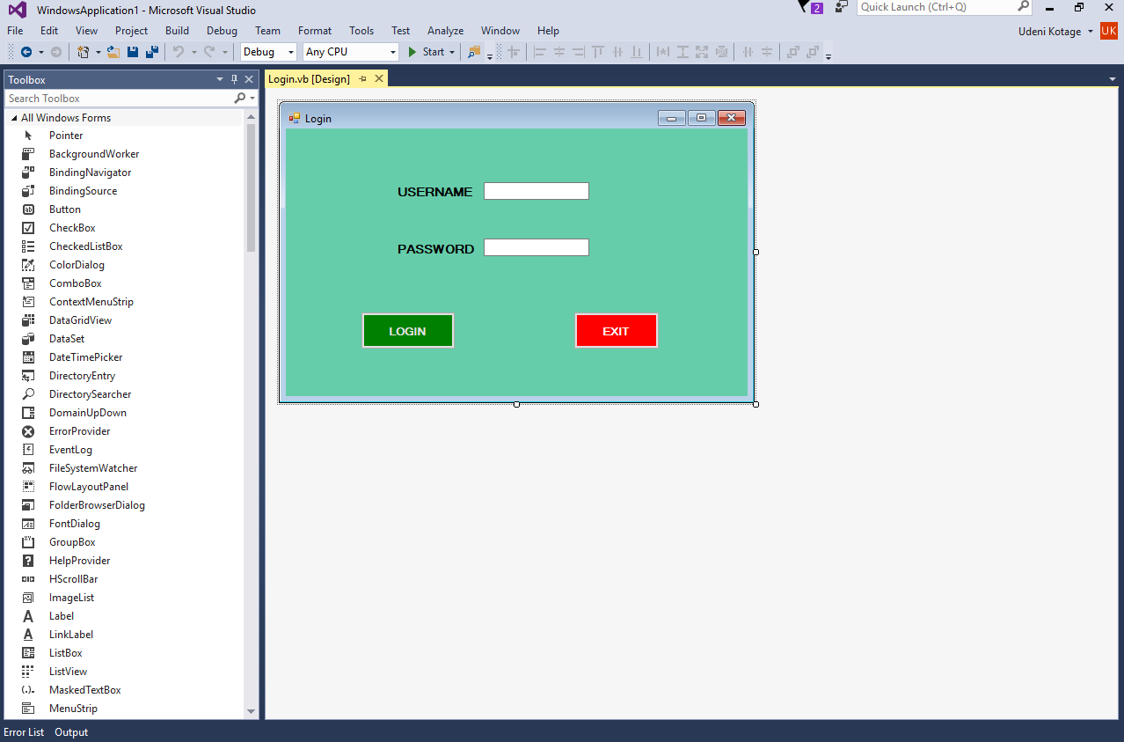

Port Selection Window:

This is the second form the users will view if they get past the Login form with correct credentials or if they have not clicked the exit button and left the program.

This will be the simplest form to design. I created the following form using a Label,a Listbox.Though not visible in the form I also added a serial port and a timer because I will need them when I start to actual program the form.

* 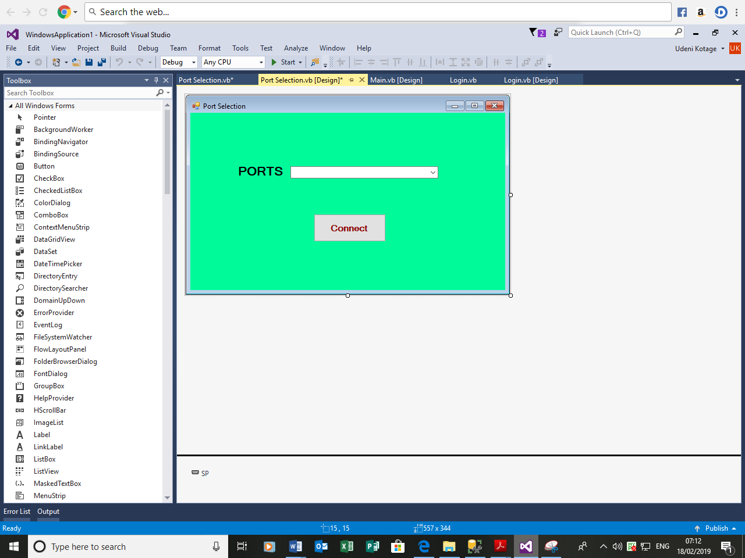Port Selection Screen

Light Green Background

Listbox

Button

Serial Port

Timer

Main Window Design:

This will essentially be the main bulk of the program. This is where the user can view the graph with Live Temperature and Humidity Readings and Input Primary and Secondary Temperatures.

I have decided to keep their whole interface within this window.I must make the program simple to use by all manner of users ranging well experienced to no experience.

The following form required a Chart, four textboxes, six labels a timer and a serial port.

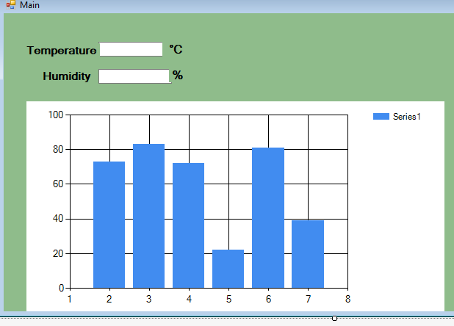

My stakeholders requested that my program should be simple to navigate and understand. I believe that this is achieved as the screen is simple in design also buttons and labels are large enough to be visible to the user, considering that one of the users have weak eyesight furthermore I have limited the number of windows in the program because that would increase the complexity of the menu structure. Before finalising this design, I decided to send this to my clients to check whether they were happy with this layout

**Dear All,**

**I have attached below a screenshot of my attempt at creating the GUI for the main menu, Please email me if any improvements are needed. Thank you.**

I received all too similar replies, it was clear that I have lacked in the presentation and the outlook of the program.

The responses were similar:

*Mr Kumarswarmy: “Could you make the layout more organised please”*

*Mr Hunt: “You have most of the major components however there should be some panel to allow the user to connect to the hardware”*

*Mr Gray: “You should separate all the different sections of the Program (inputs, outputs) to make it easier for the user to understand, you could try using group boxes to do this.”*

Final GUI Design

Following the feedback I received from my initial GUI design was made clear that I have misunderstood the client’s requirements of the GUI, however upon reading their responses gave me an insight of their expectations. Therefore I decided to change the design to suit their needs; the new GUI design is show below.

I am most focused on the hardware aspect of the program. This will be complicated and I aim to simplify this by

The Help window must be visible and easy to access therefore I will need to make sure that the help button is large enough to be seen by the user.

My final version may vary in colour however the text will still be visible.

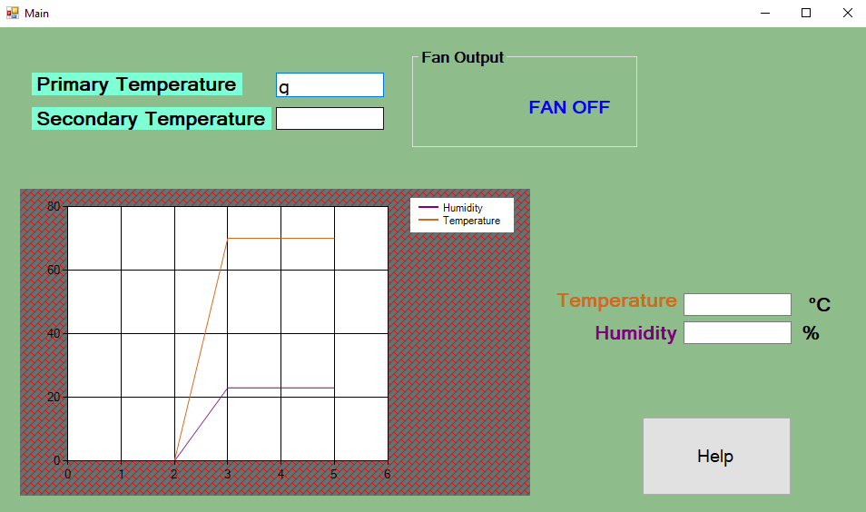

* Primary Temperature Textbox-This allows the user to Input a value to decide when the Fan should be turned on.
* Secondary Temperature Label-This allows the user to input a value to decide when the LED should be turned on.
* Graph: This will display the graph to show trends in temperature and humidity values.
* Help Button- This will allow the user to view information regarding the

Stakeholder Input

I emailed the stakeholders once more to check what I have produced against their specifications and to check if they have any further input. The email was as stated below.

**Hi,**

**I have attached below the diagrams demonstrating the outlook of the software. I have taken your input into account. I have made the buttons and everything large enough so it can be noticed by users even with weak eyesight. I have decided to keep the number of windows to a minimum in order to increase accessibility. The hardware will not be complicated to connect to and the user can do this simply by click of a button and I have improved the layout of the program. Do you have any more thoughts regarding the design of the interface?**

**Thanks,**

The replies I received are as follows.

Mr Kumarswarmy: *“The interface looks excellent. Not too complicated at all, the presentation is definitely improved”*

Mr Hunt: *“The interface definitely looks better all there left to do is to add colours”*

Mr Gray: *“Nice work. The GUI looks much better and I also believe that the presentation and clarity of your program is improved by the use of groupboxes”*

Usability Features

I have made the program simple to use by all manner of users ranging well experienced to no experience. My stakeholders requested that my program should be simple to use and understand. The design of the Screen will be simple and the buttons and labels will be large to make it more visible to the user, considering one of the user. My program will not involve too many windows because this will increase the complexity of the menu structure, and complexity makes the program less user friendly.

I will be focusing a great deal of time on the hardware aspect of the program. This will be complicated and I aim to simplify this by using problem decomposition.

The Help window must visible and easy to access so I will need to make sure than the instructions are clear and to the point.

**Modular design** **broken down to subroutines.**

Login Screen

Receive Username and Password

Port Selection

Synchronize with the Hardware to receive readings

When clicked Display Help

Hardware

Help Clicked

Main

Receive Temp, Humid Readings

Receive Primary and Secondary Temp input

Temp/Humid Chart

(Plot Real Time temperature and Humidity)

Compare Set Temp Values with real time readings

Primary Temperature

Check if the Primary Temperature Value is greater than the real time temperature to decide output for the fan.

Fan On

Second Set Temperature

Check if the Second Temperature Value is greater than the real time temperature to decide LED output

Light Output

**Top Down Design**

Turn the fan on or Off

Plot a graph comparing data

Receive Real-Time Readings

User Login

Turn the fan on or off

User Login

Receive Temperature from Hardware

Receive Username

Receive user input for Primary Temp

Check if username exists in database

Receive user input for Secondary Temp

Receive Password

Display message and ask to enter again

Check to see if Received Temperature is greater than Settemp1

Check if password exists in database

If No

If yes

If No

Tell user to turn on the Fan

If yes

Enter again

Port Selection

Check to see if Received Temperature is greater than Settemp2

If yes

If No

Tell user to turn on the Fan

Display Warning

Turn on warning Light

Receive real Time Readings

Plot a Graph

List the hardware

Initialise the axis

Check to see if Hardware is synchronised

Check to see if Hardware is listed

If Yes:

If No:

If Yes:

If No:

Refresh Button

Receive values for Temperature, Humidity and Time

Connect to the Hardware Sensor

Receive Readings

Display values

Subroutine Algorithms.

Below is the pseudo code outlining what I will produce in the implementation phase, I have labelled the non-command text with what they represent:

username = u

password = p

WHILE USERNAME == u and Password == p:

INPUT USERNAME

INPUT PASSWORD

IF Username = Username:

OUTPUT (“Login Successful”)

Open COMPORTS

ELSE :

OUTPUT (“Invalid Credentials”)

END WHILE

Receive Username

Initialise Valuese

Display Message “Enter again”

Is the username valid?

No

Yes

Receive Password

No

Display Message “Enter again”

Is the password valid?

No

Yes

Port Selection

Temp = livetemp

Hum = livehum

IF Temp<=primary temp:

Visual Warning = False

Fan=0

ELSEIF Temp>setemp1:

Visual Warning = False

Fan=1

OUTPUT Fansetting=”on”

ELSEIF Temp>settemp2:

Visual warning = True

Fan=1;

ELSE

Visual Warning = False

Fan = 0

CLOSE PROGRAM;

Extract Hardware Data

Connect to the hardware

Has real time temperature exceeded primarytemp?>

No

Make sure the fan is off.

;

Yes

;

Tell user to turn on Fan

Has real time temperature exceeded secondarytemp?

No

Make sure the fan is on but light is off.

Yes

Warning Label

Turn on warning light

Receive Temp

Temp = val1

Hum = val2

IF Val1 = Temp:

Chart. Series = Chart.Series.AddY (val1)

ELSE

Chart. Series = Chart. Series

END IF

IF Val2 = Hum:

Chart. Series = Chart.Series.AddY (val2)

ELSE

Chart. Series = Chart. Series

END IF

#

Receive Hum

;

Is Val1 = Temp

No

Yes

Add val1 to Chart

Is Val2 = Hum

No

Yes

Add val2 to Chart

PINMODE == 13

IF Settemp2 > temp

VAL == 1

SERIAL.WRITE (13, HIGH)

ELSE

VAL == 0

SERIAL.WRITE (13, LOW)

Set Pin mode == 13

Is temp => SeondaryTemp

Write (13, HIGH) to the board

Write (13, HIGH) to the board

IOPS Design

|  |  |  |
| --- | --- | --- |
| Input | Output | Process |
| Username | If correct ^ password correct: Open main window  If correct^password incorrect:Reenter  If incorrect^password incorrect:Reenter  If incorrect^password correct:Reenter | Compare to value stored in database, if incorrect ask to renter. If correct proceed. |
| Password | If correct ^ Username correct: Open main window  If correct^Username incorrect:Reenter  If incorrect^Username incorrect: Re-enter  If incorrect^Username correct:Reenter | Compare to value stored in database, if incorrect ask to re-enter. If correct proceed. |
| Primary Temperature | If exceeded display visual warning.  If not exceeded proceed. | Compare with real time values to decide outcome. |
| Secondary Temperature | If exceeded set fan value to 1  If not exceeded display visual warning and proceed. | Compare with real-time values to decide outcome. |
| Real-Time Temperature | Graphical output, form of line graph. | Open Chart and start plotting. |
| Real-Time Humidity | Graphical output, form of line graph. | Open Chart and start plotting |

Data Structures

|  |  |  |  |  |
| --- | --- | --- | --- | --- |
| **Variable** | **Data type** | **Example** | **Visibility** | **Comment** |
| Username | **String** | Roy | Local Variable | The Username value can be input into system via a textbox. This will be validated by comparing it to a value in the database. |
| Password | **String** | GY | Local Variable | Password can be input into a system via textbox. This will be validated and compared to a value within the database. |
| Primary-Set Temperature | **Integer** | 17 | Global Variable | The primary temperature value the user can input into the system via a textbox. If exceeded user will be visually alerted. |
| Secondary-Set Temperature | **Integer** | 20 | Global Variable | The secondary temperature value that the user can input into the system via textbox. If exceeded user will be visually alerted and the fan value will be set to TRUE. |
| Present Temperature | **Float** | 14.85 | Global Variable | The displayed Temperature, indicating the current value for Temperature. This is demonstrated by means of the graphical chart. |
| Present Humidity | **Float** | 13.47 | Global Variable | The displayed humidity, indicating the current value for humidity. This is also demonstrated by the graphical chart. |
| Fan | **Boolean** | OFF | Global Variable. | This indicates whether the fan is on or off. If the Secondary Temperature is exceeded then the fan will be turned on. |
| Warning | **String** | Warning | Global Variable. | This warns the user if the primary temperature is exceeded. |
| LED | **Boolean** | ON | Global Variable | This turns of if the secondary temperature is exceeded. |
| Temperature Chart | **2d Array** | X,y | Global Variable | This plots live readings of temperature and humdiity |

Validation and Verification

In order to ensure the effectiveness of my program must validate all user input. I will enforce the following validation checks:

* The Username is required and must be equal to the value stored with the database.
* The password is required and like Username it can only be equal to a certain value stored in a database.
* The primary temperature is required and can only be in integer format.
* The secondary temperature is required and like the primary temperature it can only be in integer format.

In order to make the program robust I must validate all user input. Users can input data via Textboxes. When users enter data into the application, I must verify the validity of data is before the application uses it in order to reduce the chance of crashing the program. Inputs must be in different formats (text for the login credentials and integers for temperatures) furthermore I must ensure that text fields not be zero-length, luckily Windows Forms provides several ways for me to validate input in my application.

I will mainly be using explicit data validation where data is validated at one time and data can be validated in response to a user action such as clicking a button. When the user action occurs

Buttons:

Buttons must be linked to something otherwise when pressed, nothing will happen. Therefore I will need to make sure that the buttons are linked with textboxes to receive input

Textboxes:

Textboxes must be validated otherwise the user can enter invalid data(eg from invalid data types).For primary and secondary temperatures I will need to use text boxes to receive user input and I must validate the textboxes in order to make sure that only integer values are accepted . I must make sure that textboxes are also linked with the hardware so that live readings can be displayed on textboxes.

# Testing

I must make sure to test each function after creation in order to make sure they work as intended. Further testing could be carried out to find errors or areas of improvement.

In the development stage of the program I will need to input data into the program such as the Primary Temperature and check if the expected result is obtained. If any crashes occur during this I will analyse the content of the code for debugging.

I will then use Destructive testing and enter incorrect or extreme data and check how program handles this for example for primary temperature I will enter extreme data such as @###£$ and see how the program deals with this will keep a record of the data I input. After my program is fully developed I will then present it to the user.

The hardware will consist of a sensor and a warning light and will need to be tested extrensively in order to ensure that they work as expected.

It is vital that the sensor is setup and tested properly, I will ensure that it receives valid readings and also that the sensors are able to detect changes in background temperature. I will run tests by making the surroundings warmer and colder and then observing the readings to check for changes, I can observe the readings via the Arduino IDE.

I will create a test plan in the form of a table to keep track of all the tests that I will carry out including destructive and usability testing. The tests will clearly be separated using their respective IDE’S (Arduino and Visual Basic). I will clearly compare the outputs with the expected outputs and identify each test with a test id.

Test Plan

Visual Basic

|  |  |  |  |  |  |
| --- | --- | --- | --- | --- | --- |
| Test ID  ]  Arduino | Test Objective | Inputs/Actions taken | Expected output | Actual Output | Reason for testing |
| 1 | Check If the username and password ignored and asked to enter again if it is not equal to a one stored in database? | Input 180321 and check if error is displayed | Display error message and ask to enter the username again |  | This will ensure that the user input is compared against database values to decide whether or not to grant further access. |
| 2 | Check if next page displayed when the credentials are correct and the login button is pressed? | Click the Login Button after entering valid Credentials. | Open the Port Selection page |  | This will make sure that the user is given access to the program if the credentials are valid. |
| 3 | Check if clicking the exit button closes the form. | Click the exit button. | Close the form. |  | This will make sure that users can exit now if they do not wish to see the program. |
| 4 | Check if the hardware will show up on the selection if it is not connected | Disconnect the Arduino from the computer then attempt to connect to the port. | Do not display the disconnected hardware on the dropdown box |  | This is a check to ensure that by this point all the hardware is connected properly. |
| 5 | Try to see if sensor values are received without connecting hardware | Disconnect the Arduino from the computer and try compiling the program | Do not receive any readings |  | This will be yet another check to ensure that all hardware should be connected properly. |
| 6 | Try to see if  Sensor values are received by connecting the hardware but disconnecting the sensors | Disconnect the sensors from the board but keep the hardware connected to the computer. | Do not receive any readings |  | A check to ensure that the sensors are connected/calibrated properly. |
| 7 | Try to see if increasing the temperature causes the received values to increase | Use a cup of hot coffee and place near the sensor to allow the sensor to read this | Temperature should increase |  | To ensure that the sensor works as expected and can detect a rise temperature |
| 8 | Try to see if decreasing the temperature causes the received values to decrease. | Use an ice pack and place near the sensor to allow the sensor to read this. | Temperature should decrease |  | To ensure that the sensor works as expected and it can detect a fall temperature |
| 9 | Check if the system was able produce a graphical chart of live temperature and humidity | Check if the chart has been produced | Produce a graphical; chart displaying real time temperature and humidity |  | To make sure the user can view trends temperature and humidity. |
| 10 | To see what happens when text is entered into Primary temperature box | Enter “Hello” into the primary Temperature Textbox | Program to ignore text, displays message and asks for input again. |  | To make sure that the user’s input for Primary Temperature is in a valid (integer) format. |
| 11 | To see what happens when text is entered into Secondary temperature box | Enter “” into the Secondary Temperature Textbox | Program to ignore text, displays message and asks for input again. |  | To make sure that the user’s input for Secondary Temperature is in a valid (integer) format. |
| 12 | To see if the Fan turn on when Primary temperature is exceeded? | Input a primary temperature greater than the current reading  Expect a warning label. | Program alerts the user than the fan is turned on. |  | To make sure that the user is able to adjust the temperature which can cause the fan to turn on. |
| 13 | To see if the LED turn on if the live temperature is greater than secondary temperature | Input a primary temperature greater than the current reading  Expect the LED to turn on. | Program writes to Arduino allowing LED to turn on. |  | To make sure that the user is well warned if the temperature reached extreme levels and they are able to adjust the temperature that triggers this warning. |
| 14 | To see if the help button displays information regarding interface navigation. | Click the help button | Program displays instructions on how to navigate the program. | As expected | To ensure the users have sufficient knowledge on how to navigate the interface |
| 15 | Is the Warning Displayed clearly if the live temperature is greater than secondary temperature | Input a Secondary temperature greater than the current reading  Expect a warning label. | Program changes the colour of the camouflaged warning Label to Red. | As expected | To ensure that the hardware list is refreshed to make sure that the correct hardware device shows up on the screen. |

Development

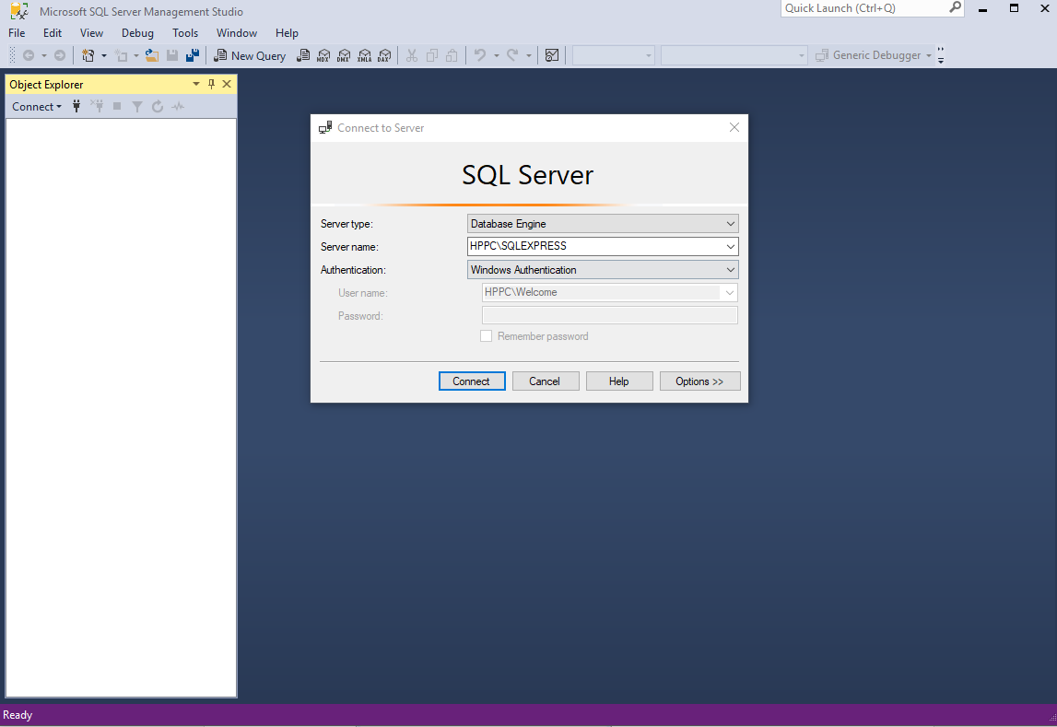Before starting to develop the program I must setup the database. I have created my database required for the Login Form by using SQL Server management system, the data from this database can then be accessed by visual basic via SQL Server. After installing SQL server management system in my home computer I will then start the design of the database. For the default instance of SQL Server, the server name is the computer name.

Connecting to SQL server – After connecting to the server I have opened a new query and used the The knowledge I received from this course proved more than sufficient enough to implement following code to create the database and added a table called logincred.

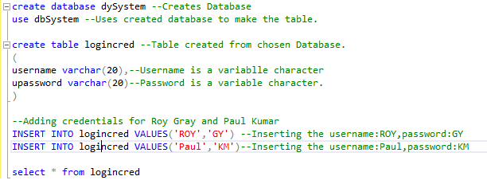

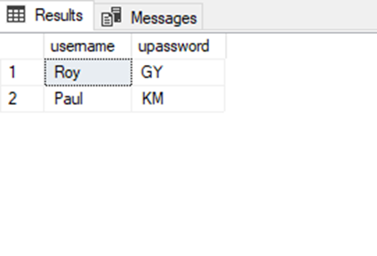

Now that I have created a database storing the credentials can now begin the design of the loginform. This will be the first screen the users view, this will decide whether or not to grant the user further access to the program will open up visual studio and Start a new Visual Basic project.I will create a windows forms application called Login, this will open up an empty form.

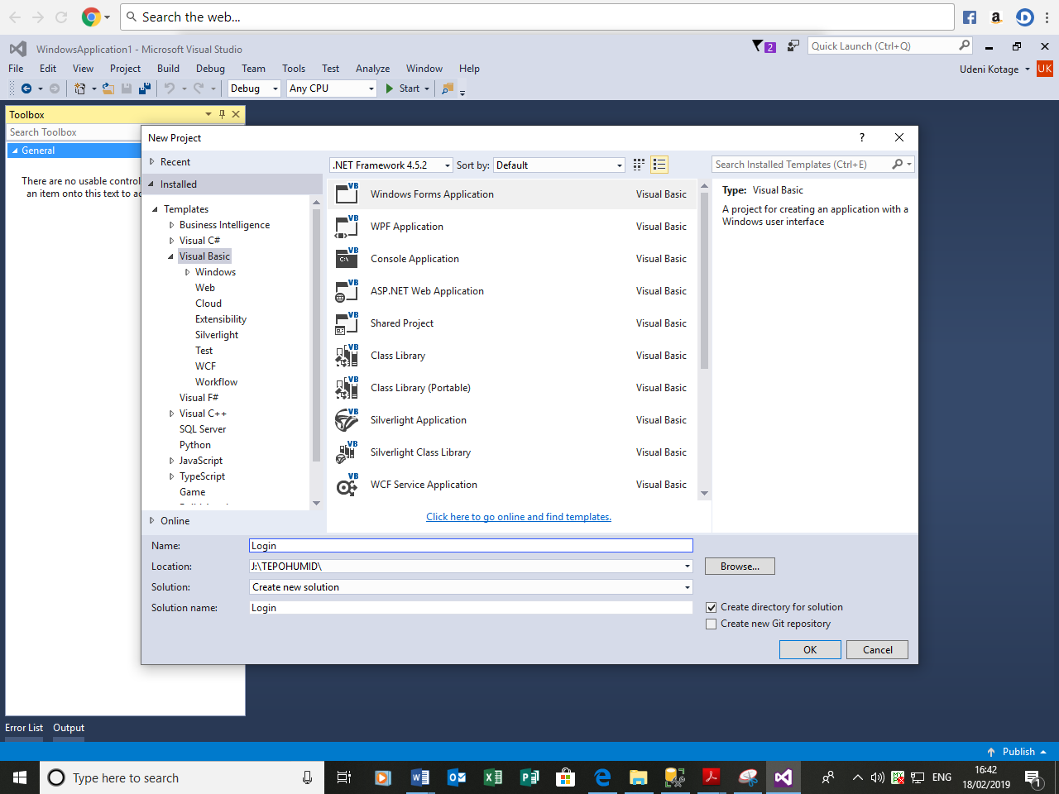

To design the login form I will need require two labels, two textboxes and two buttons.I will follow the planning in the design section for this form(pg.) by Making the background Light Green, Labels black and the two buttons Green and Red(Login and Exit).I will add text to the labels as Username and Password then I will add text to the buttons as Login and Exit.

Now that I have made the changes, the login form looks like this.



Now that I have designed the form what I must do now is to retrieve the values from the database I created using SQL Server Management System (see page 1).I must retrieve these values into visual studio because I will need to compare these values to the user input.I will do this now since it is a simple task to carry out and will save time doing this in later stages. I will be using visual studios’ built in SQL server object explorer to do this.

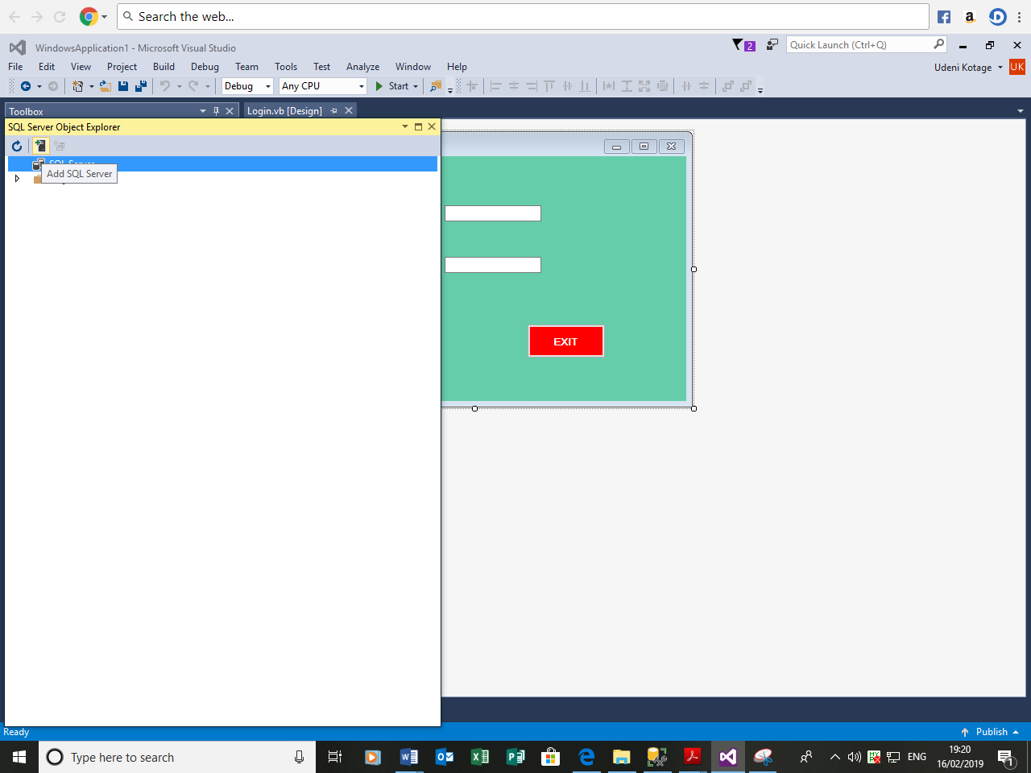Firstly I will click on View to access SQL Server Object explorer.

Then I will click Add SQL Server and enter the server name which I copied from SQL Server Management Studio(page 2) and I will connect to the database by Simply Clicking the connect button.

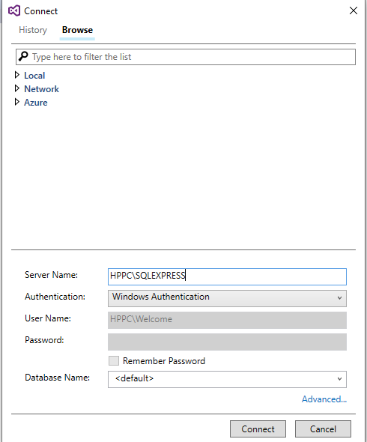

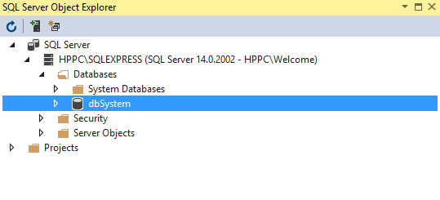

Now I can see that the database I created earlier (dbSystem) is listed under System Databases on SQL Server Object Explorer, now I can have access to the database from Visual Studio.

Now I will begin the programming the Form.I have named the Login button as loginbtn, Exit button as btnexit.I have named the textbox for Username as txtuser and textbox used for Password as txtpass. By clicking on the Login Button twice on I will open up the event handler to start the programming.

First Step is to make sure that some input is received from the user so I must make sure that no text box can be left empty when the user clicks the Login Button. I used the following code in order to do this.

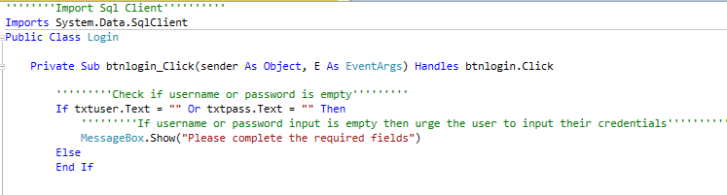

If the user attempts to submit the form without entering any data into the textboxes then a message will be displayed to urge them to do so.

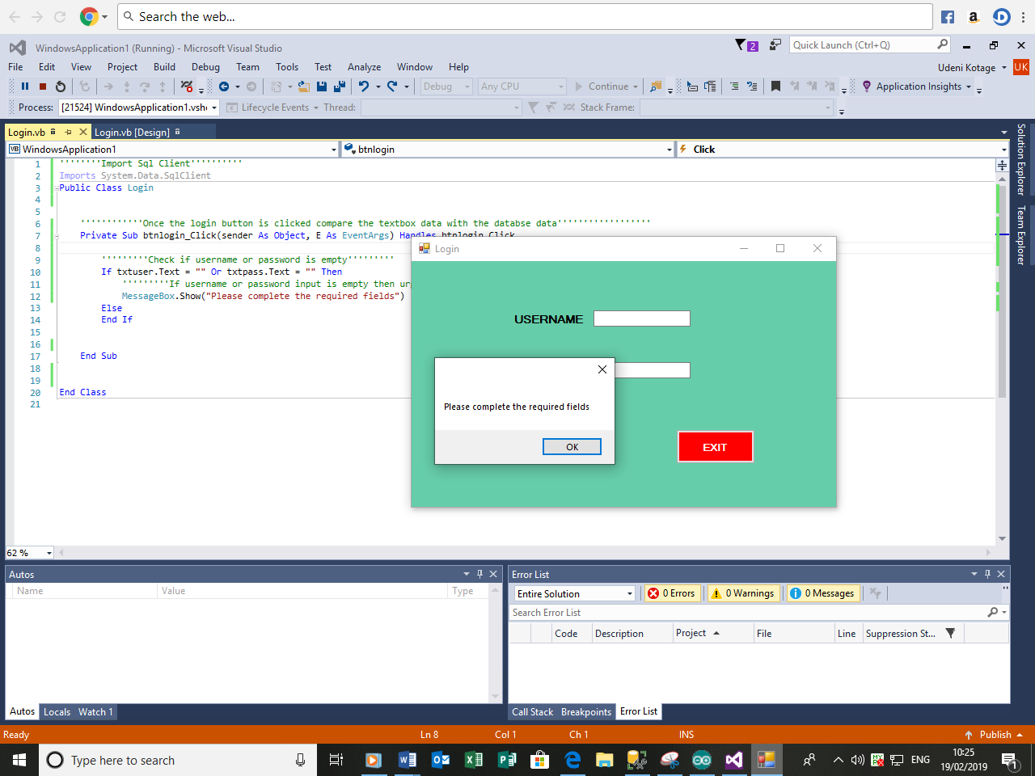Now I will test this, I will now run the program and attempt to click the login button without entering anything for the textboxes.

When the program is run, it works well and this message is displayed. I will now program further to compare the user input with the values from the database. Since I have already extracted the database from Sql Server Management studio into Visual studio.

By using tutorials from <https://www.instructables.com> and <https://www.vbtutor.net> I quickly developed sufficient programming knowledge to receive and compare the values from a database with the values input into a textbox. To ensure that the only the credentials matching those stored in the database can access the system, I must validate the textboxes.

In order to connect the loginform to the database I must find the connection string, this can be found by navigating to SQL server object explorer and accessing properties.

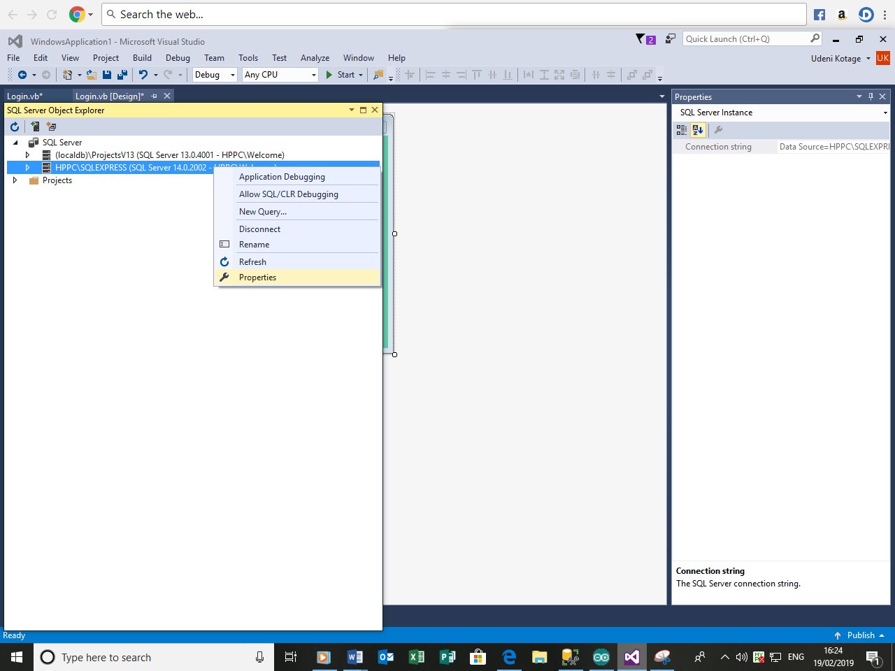

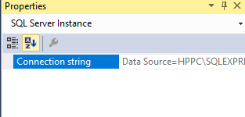

The following lines of code will allow me to connect to the database and select the values for the username and password from it.

Name of the server which I am currently connected to.



‘SqlConnection’ creates a new connection to the database using the Connection String.

The Astrerisk (*) demonstrates that every column on the table logincredentials that I’ve created earlier on matched record in WHERE condition output. By using an AND comparison (&) both credentials are checked to see if they are true so the username must match or it will fail.

Now I will set up the parameters and assign them to the appropriate textboxes.

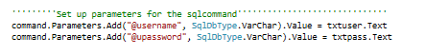

Now I will use the following lines of code to hold the information from the login and compare the information to the ones received from the user.

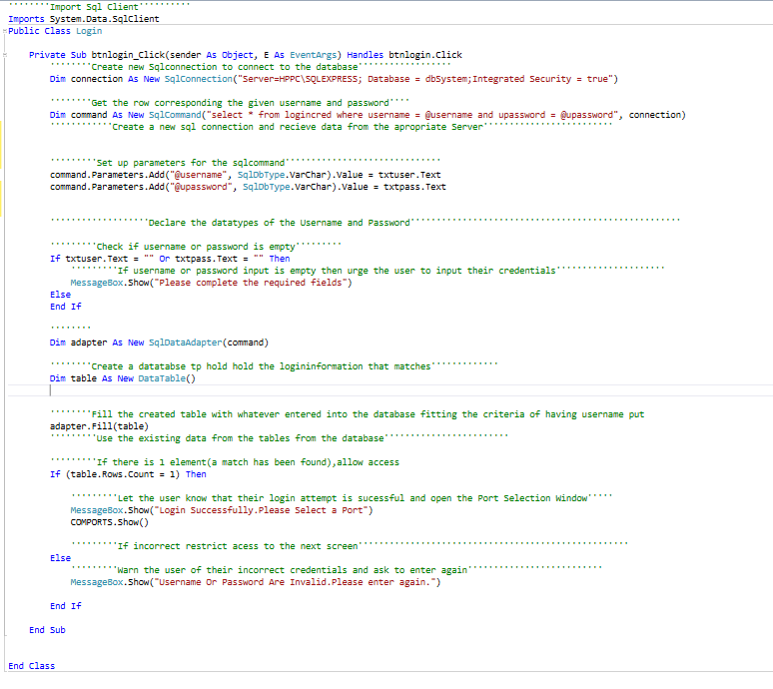

SqlDataAdapter is simply used to provide the communication between my Dataset and the Data Source using the SqlConnection Object. The SqlConnection Object has no information about the data it retrieves. Similarly a Dataset has no knowledge of the Data Source where the data coming from. So the SqlDataAdapter manage the communication between these two Objects.

Now that the login form has been created as expected, I now need to design and program the comport selection form. I will add another form to begin the design.

I created the Form used to select the hardware ports. This form was the simplest form to create as it only required a button, a combo box, label and a serialport. I named the combobox as cbports, the button as btn connect and the serial port as SP.This form will list the connected hardware device and if not connected it will not be listed.



Firstly I used the following lines of code to set up the ports.

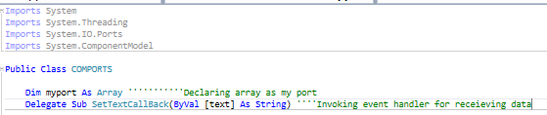

By clicking on the form I will now list all the ports which have device connected to them.

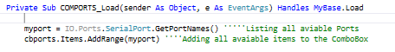

By clicking the connect button the user is taken to the main form.

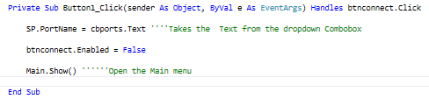

Now I must proceed with the project and implement receiving of live temperature and humidity values. My initial knowledge of Arduino programming was reasonable yet I required a little more support with programming the DHT11 sensor in order to carry out this program so I used the following websites to further my knowledge <https://www.arduino.cc> , <https://www.brainy-bits.com> and <https://www.instructables.com> .

Essentially Setting up the DHT11 sensor is simple once I understood how each of the pins work.

|  |  |  |
| --- | --- | --- |
| Pin No | Pin name | Pin Description |
| 1 | Voltage | Voltage supply of 5v. |
| 2 | Output | Output pin for reading DHT11 data. |
| 3 | Ground | Ground pin has 0v. |

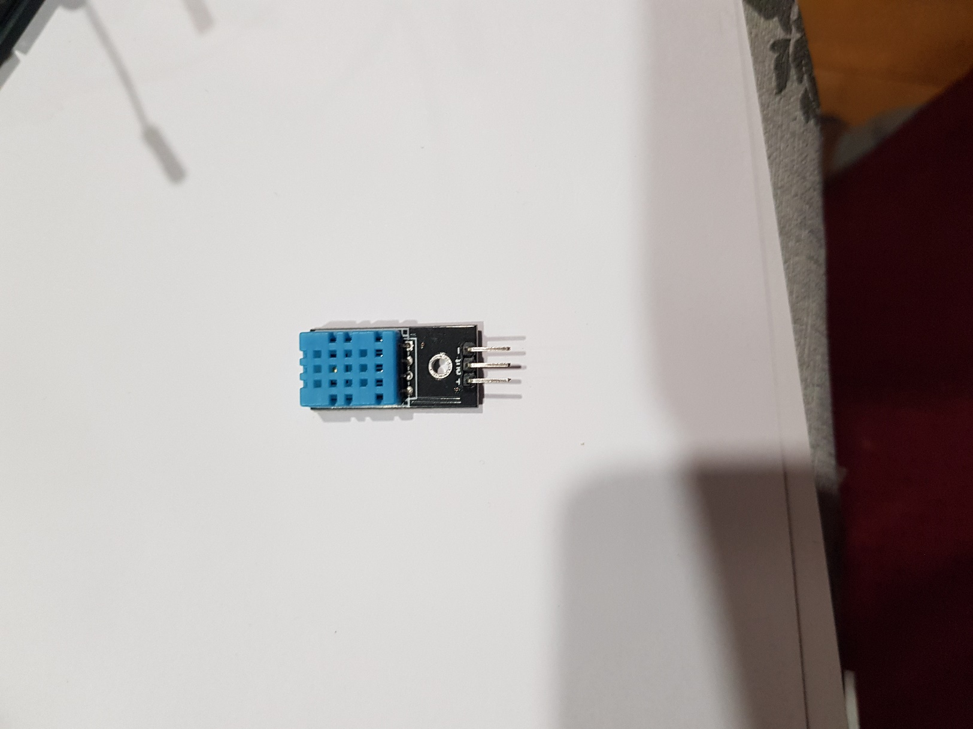

Figure 2

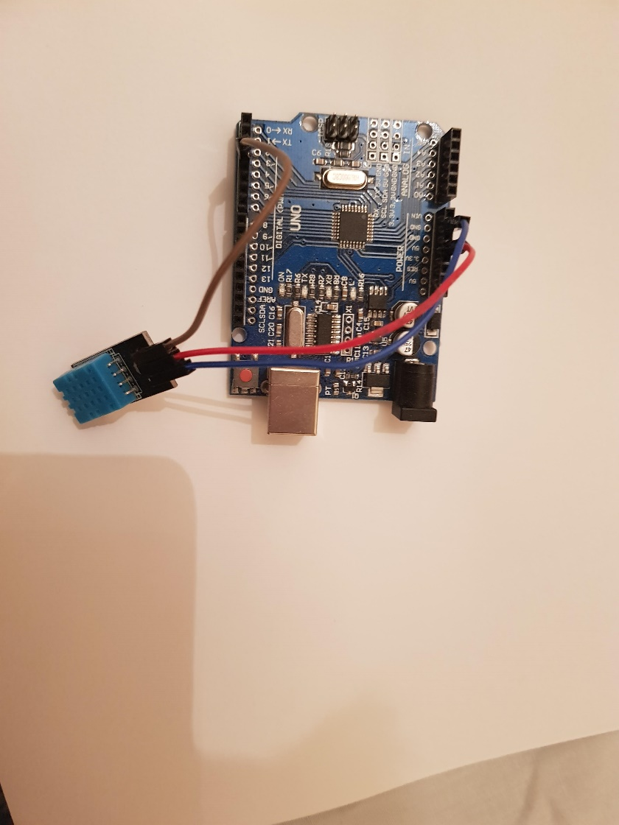

Voltage

Ground

Output

Figure 1

Figure 3

The above figures are used to demonstrate how I have connected the sensor to the Arduino, the table in Figure 2 has been coloured Blue, Red and Brown in order to represent the colour of the wires and hence clarify where each wire should connect to.

Figure 1 and Figure 2 details the pins associated with the DHT11 sensor.Figure 3 shows how the sensor should be connected to the ardunio(the resistor is not required because my arduino board has a built in resistor) using jumper wires.

I began the code by including the library which is essential for the sensor. I have downloaded the library from <https://www.arduinolibraries.info/libraries/dht-sensor-library> and added it to the program. As shown in figure 2 once the library has been added it will be listed under libraries

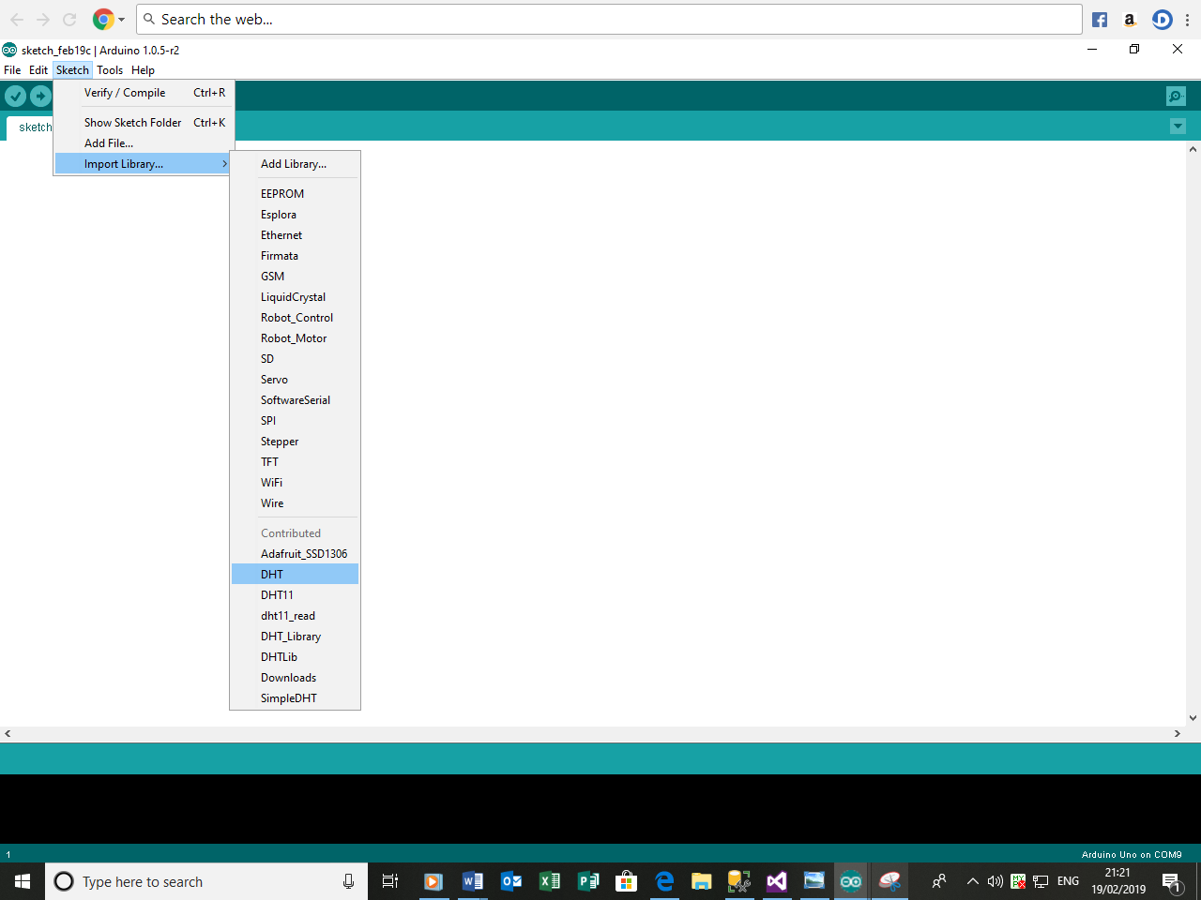

By clicking on the DHT library from the list includes it into the program as shown below.

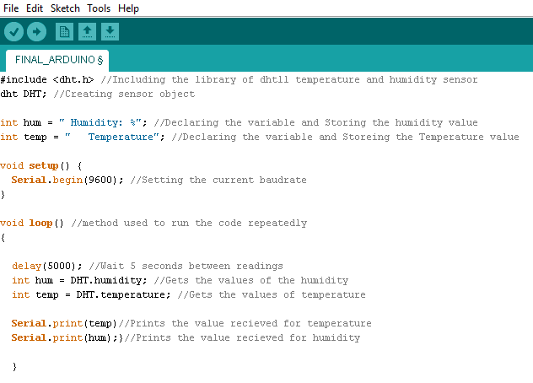

This is my first attempt of the program, it is relatively simple to code and required little effect. I declared the variable for humidity (‘hum’) and temperature (‘temp’) as integers. I will now attempt to upload the program into the board

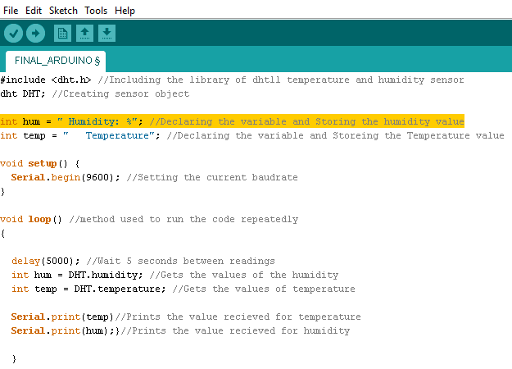

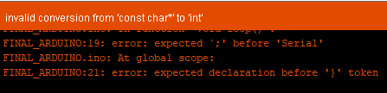

I was unable to upload the program due to the following error. This error is simple to fix and changing the value from



By adjusting the value from integer to String solved the issue



It seems there is yet another error that stops me from compiling the program.

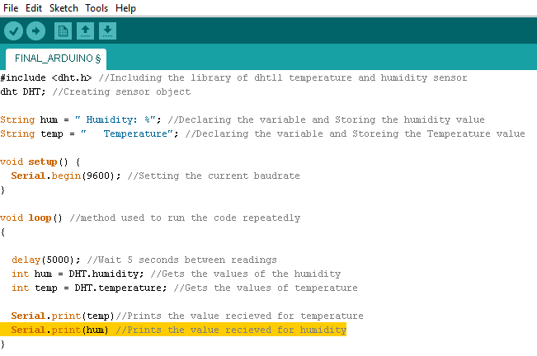

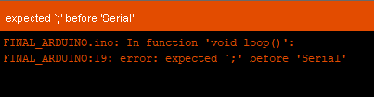

However this is a simple syntax error so it was easy to fix.



Simply inserting a colon after the Serial.Print (temp) statement was sufficient to fix this and get the program to upload.

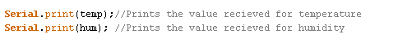

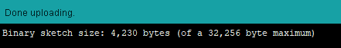

Now that the program has been uploaded to the board I will click the view serial monitor button to see if the readings from the sensor be displayed.

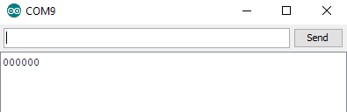

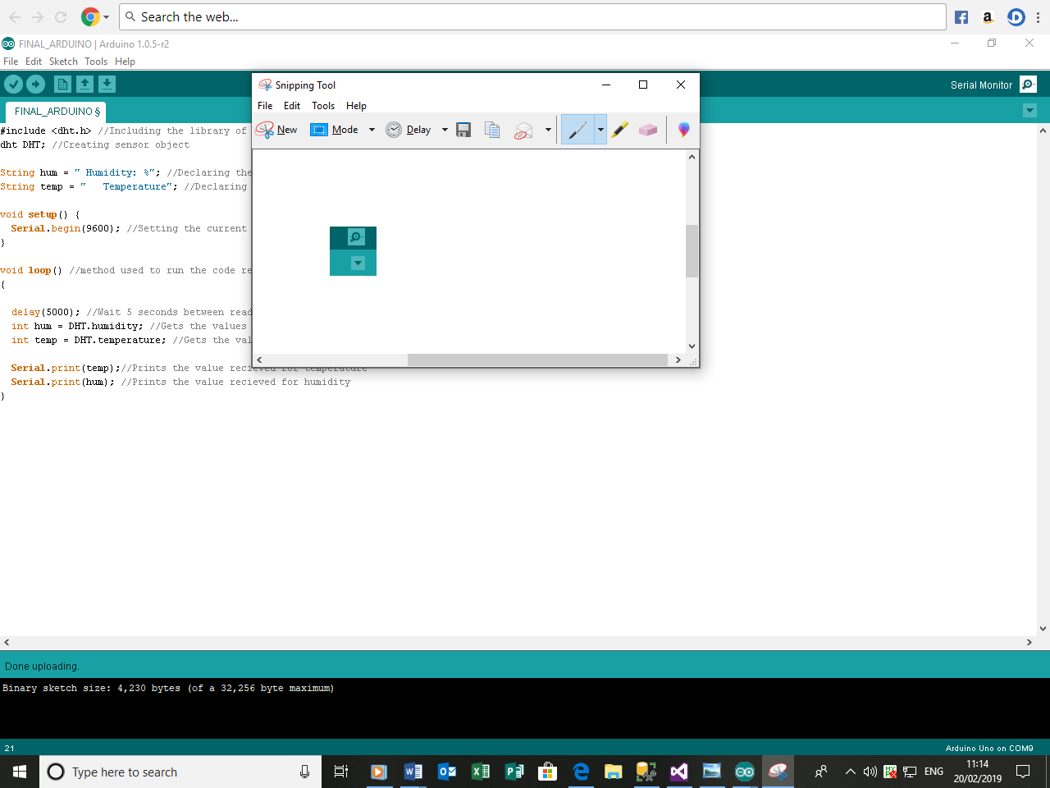

However the output was not as expected as I dint not receive any values I required. I soon realised that this is simply because e I have not told the program what pin the sensor is connected to, without knowing it the program could not receive the readings.

I used this line of code at the top of the program to define the pin I am connected to.



This line allows the data to be read from the Arduino.



Once I uploaded the code and opened the serial monitor, the following results are displayed

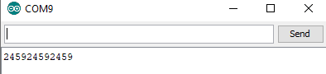

Now I can finally see some readings however the readings for temperature and humidity do not seem to be separated so it is difficult to read and understand so I used the following .

Firstly I declared a new value called TotalReading as a string 

Once declared I used this variable in order to combine temperature and humidity values and separate them using a comma.



I will upload the code once more and view the serial monitor to check if the temperature and humidity values will be separated.

Once I have done it the following results are obtained

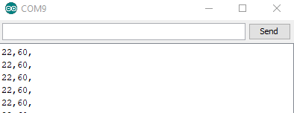

Now finally I can view the temperature and humidity values as stated in the success criteria.

Now that I have successfully managed to receive readings from thee Arduino now I must return to visual basic and work on extracting those readings into a graph.I returned to visual basic where I finished programming the port selection page and added a new windows form titled Main

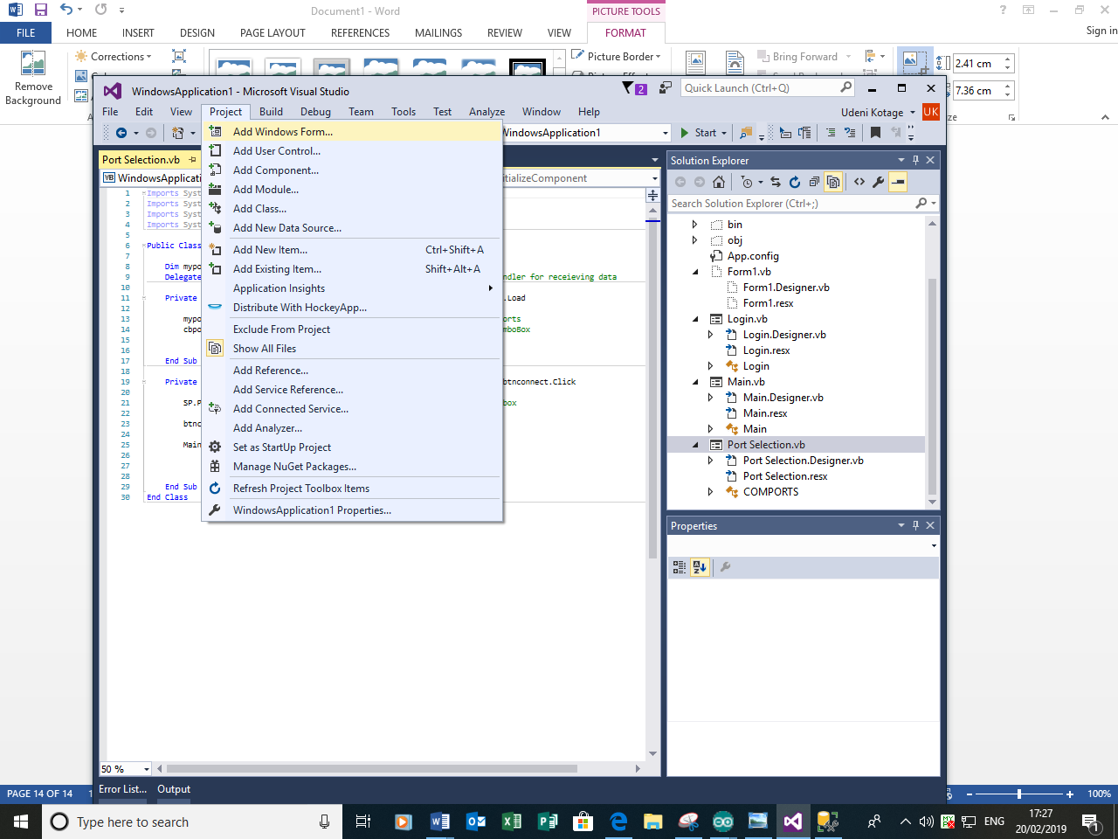

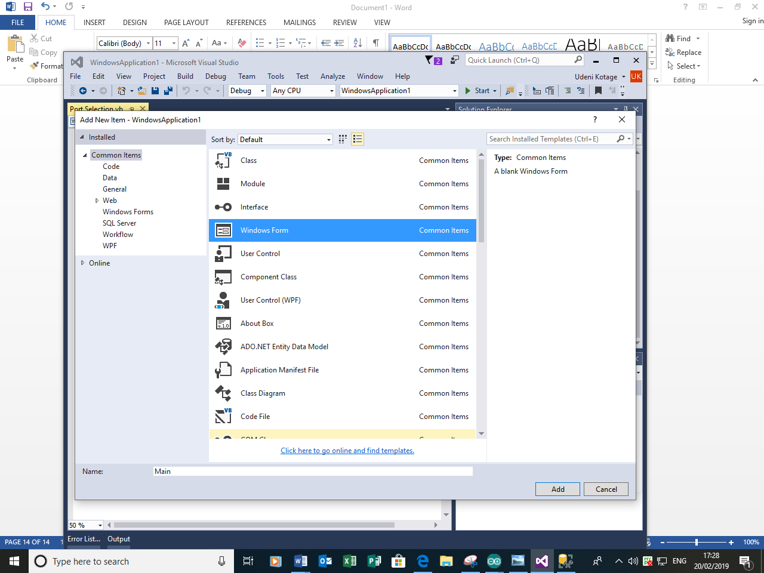

Once the form is added I Added a serialport, a timer four labels and three textboxes. I used two of the Labels to label the values that will be output into the textbox, these will be the obtained values for temperature and humidity. I used the other two labels to show the corresponding units for them. I added the serial port because this is needed to receive the necessary values from the hardware. One of the textboxes will be used to extract both the temperature and sensor values from the sensor; those values will then be split and separated into the respective boxes.

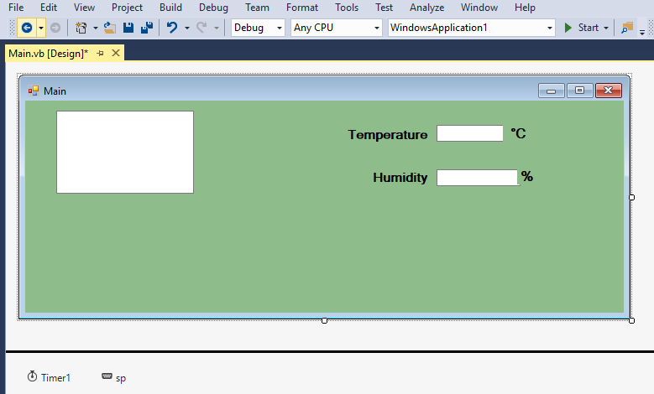

Firstly I will need to program the serial port to receive the necessary values. In order to do this I need to use namespaces so I used ‘Imports System.IO’ and ‘Imports System.IO.Ports’ to import all the necessary namespaces for this form.

Then I used the following code in order to set the appropriate properties for my Arduino. My Arduino is an Arduino Uno with a badurate of 9600.Serial port class uses encoding specified by the Serial. Encoding property to convert strings and character arrays to bytes to send across the serial port

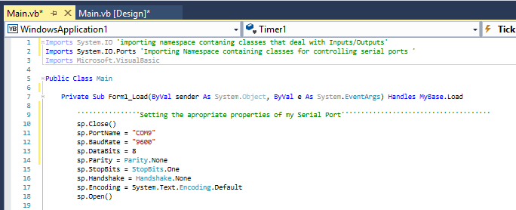

I will not run the program yet simple because the following programming will have not visible effect on the form.

Now I will begin programing the timer.

I have decided to name this timer as TimerSplit because the code I use within this event handler will mainly be used to split the data from a textbox into two separate textboxes (I will provide more information when I actually program this).

By right clicking on the timer and accessing properties I can make sure that the timer interval is set to 1000 milliseconds (1 second).This property simply defines how much time will pass before the procedure is run again.

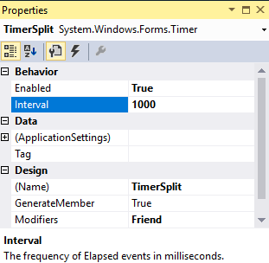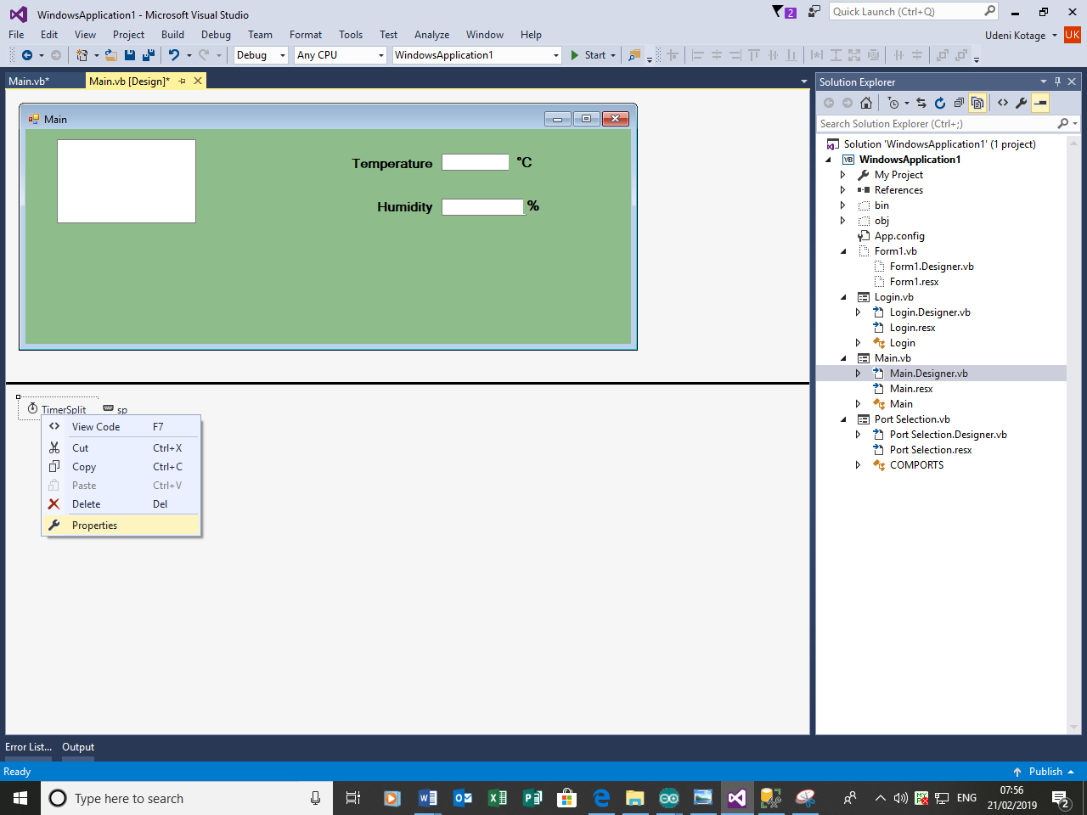

I will start off by programming Textbox 1 which is where the values for temperature and humidity are received together.

Firstly I declared a vaue called TotalReading,this is the value we receive from the arduino,to clarify what I mean I will revisit my arduino code to show that temperature and humidity valeus are receieved combined together into one variable.

The Following arduino lines of code demonstrates that I have declared a variable called TotalReading where I combined the readings of temperature and humidity into one string.I have explained this section of my arduino code previously when I began to attempted to receive values from the Sensor,which I have sucessfully completed.





Rturning to visual basic I now need to get the same value of TotalReading into textbox total which I will later split into their respective textboxes.



Total reading will hold the values which we receive in the textbox Total. Text plus we add the delimeters.We are adding delimiters is in case we receive an empty message from Arduino.

At this stage I realised that I have not actually received any readings yet, I must receive readings into textbox Total before splitting the data into two separate textboxes!

I returned to the main form and navigated to Serialport (sp) and accessed it’s properties then went onto events .Now I can double click Datarecieved event handler to start programming.

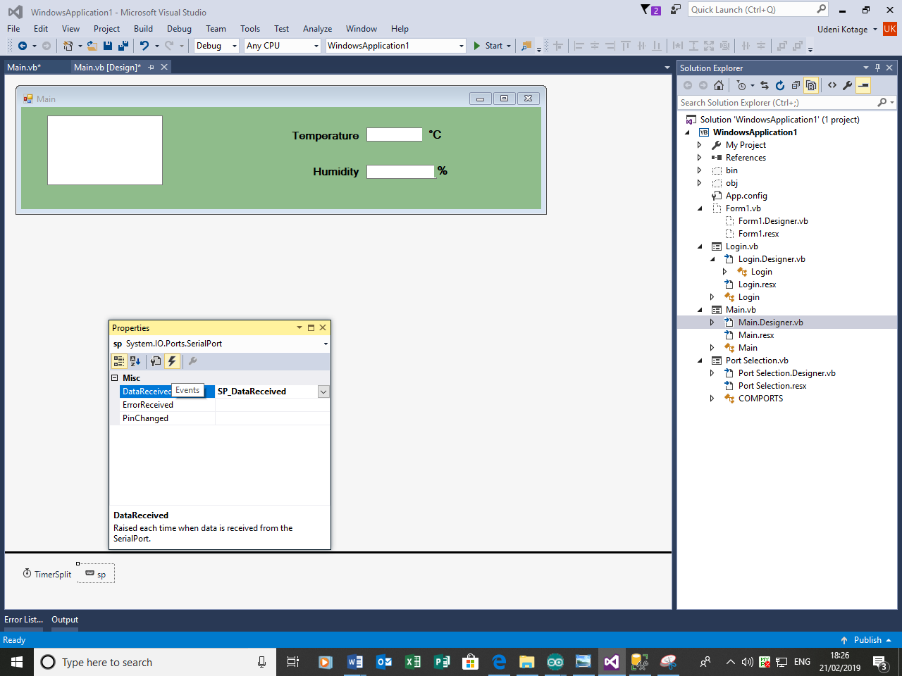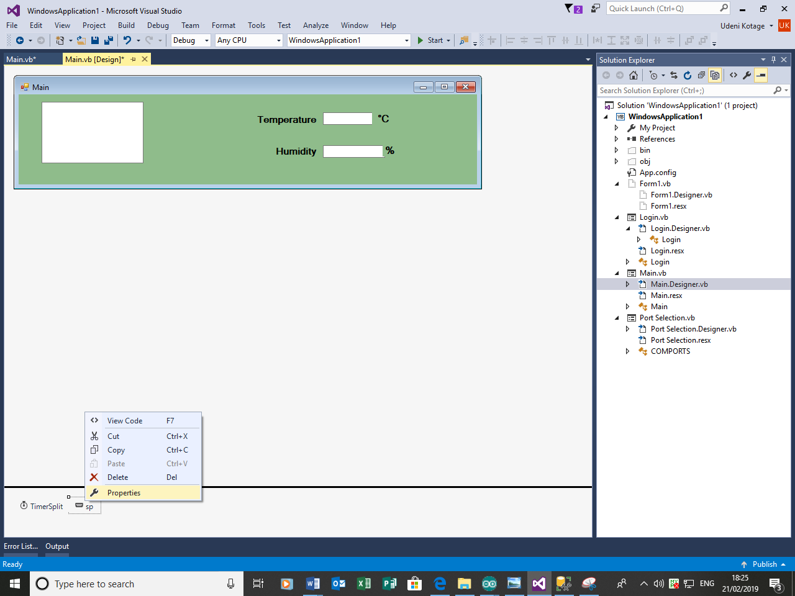

This is the following code I used in order to receive the values from the serial port.

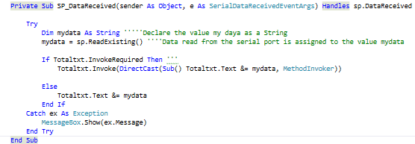

Now I will run the program in order to ensure that the program runs as expected.

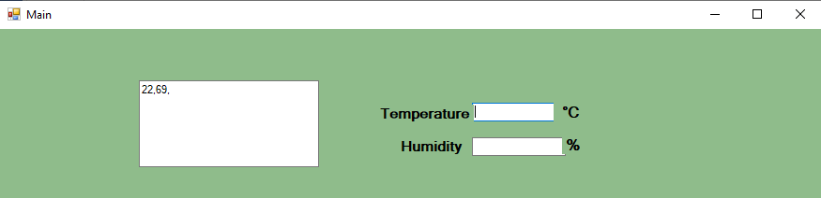

Now that I can successfully receive the readings into a textbox now I must separate the values into their respective textboxes. In order to achieve this I need to implement a ‘split’.

Returning to the following code I begin implementing the split.



I added these lines of code



By introducing the variable called reading, I will use this variable to define the split.

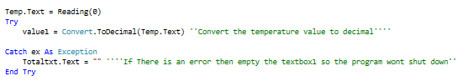

This is the attempt at extracting the value of temperature into the textbox.

The same code can be used for the humidity however I must change the parameter, so it would look like this.

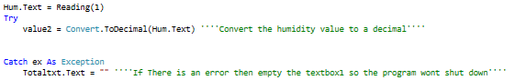

It can be observed that both codes are of similar structure, only difference in fact is the position of the value reading(0).Now I will run the code to ensure if the split has been performed.

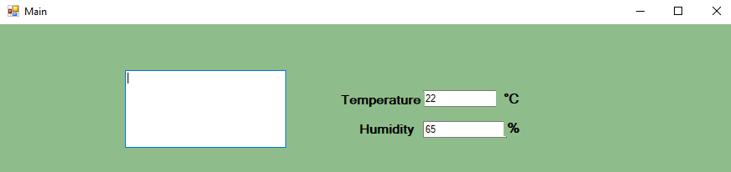

As expected I have managed to split the total values into their respective textboxes. Now that this is successful, I will hide the total textbox (the textbox the values are received to prior to the split) by adding it to the bottom of the form, reducing its size and changing its colour and the colour of its text so it blends with the background, the point is I do not need it visible however it is very essential to understand that it cannot be deleted.

After making the totaltxt textbox as small as possible(Fig 1),changing its properties to blend with the background(Fig 2) ,making the size of text as low as possible(fig 3),the textbox is now invisible to the user to the user, as shown in in figure 4.

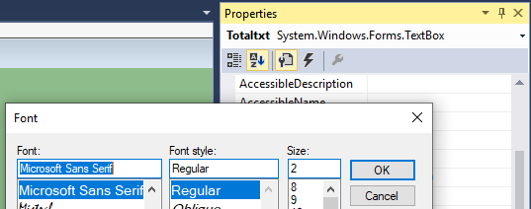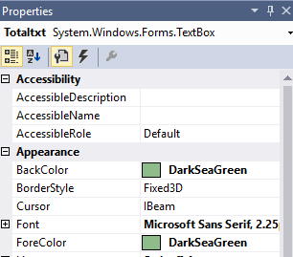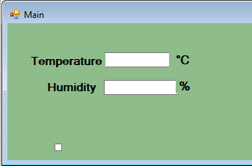

Figure1

Figure3

Figure2

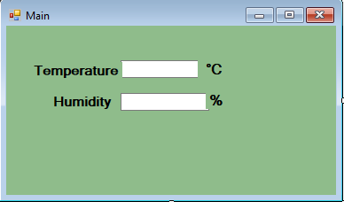

Figure4

Now that I have successfully managed to retrieve values for temperature and humidity and separated them into two deferent textboxes, I will now plot these values into a graph.

Firstly I added the chart by navigating to toolbox and searching for charts, and then I dragged in into the form.



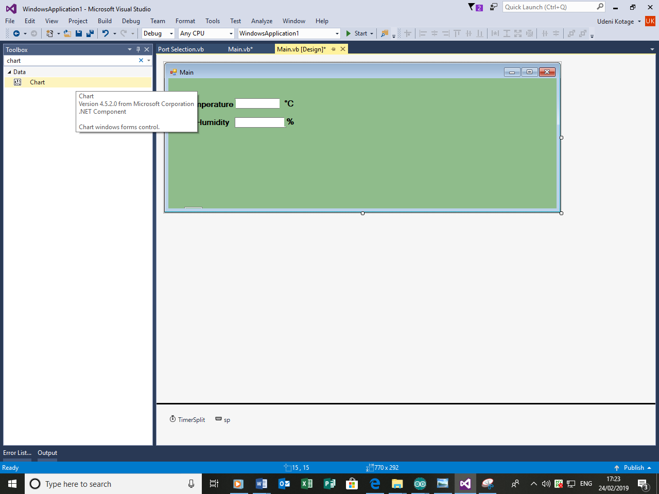

Once added I noticed that the chart is a bar chart, I want to change this to a line graph because I believe that line charts are better at comparing changes over time and I find that it is generally good for continuous data.

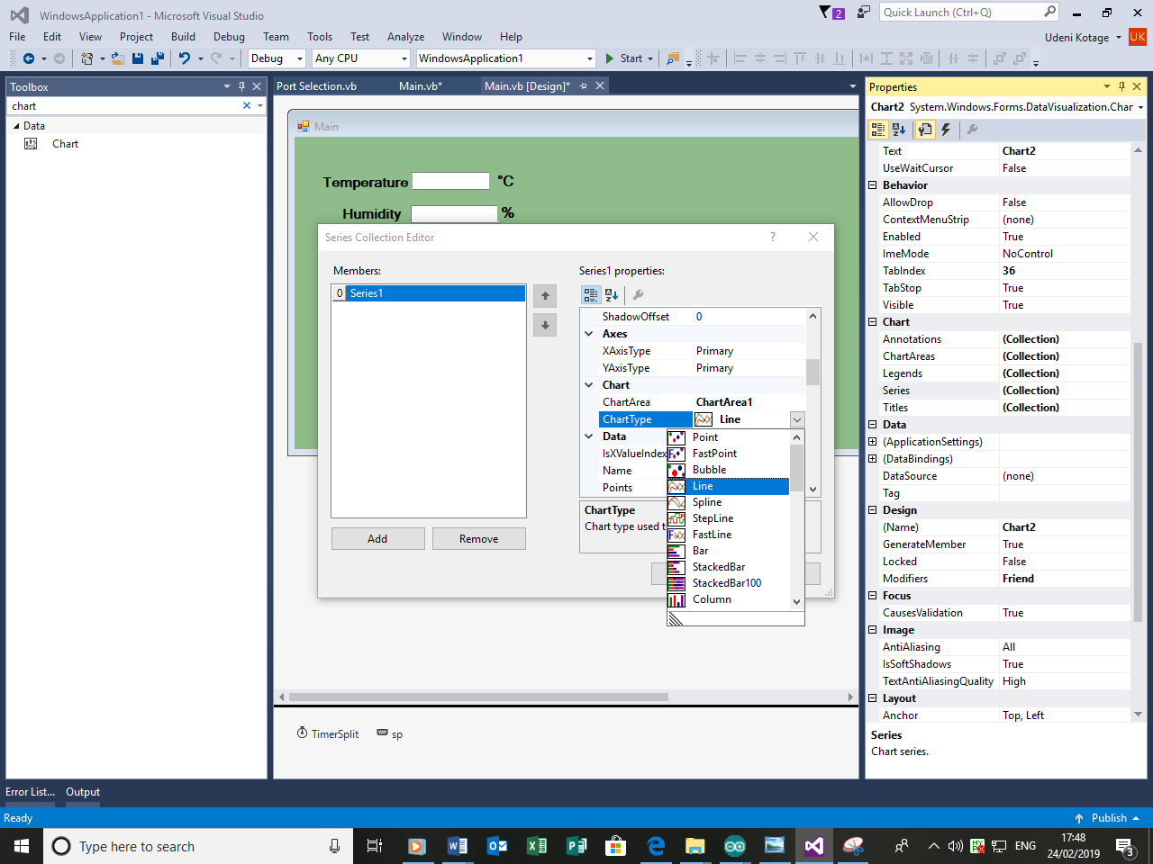 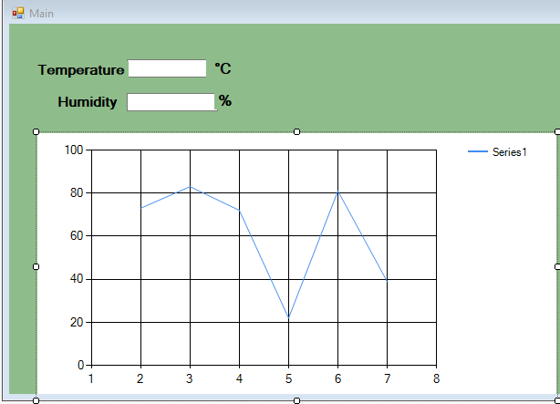

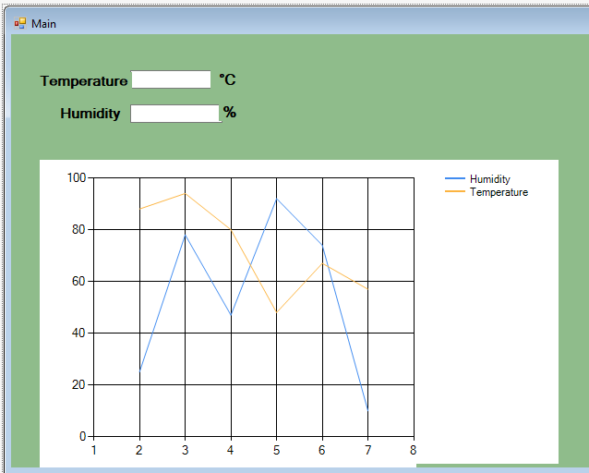Now I will add the values of temperature and humdiity into the graph.This will be easy to do because I have already assigned the values of temeprature and humidity as value 1 and value 2.

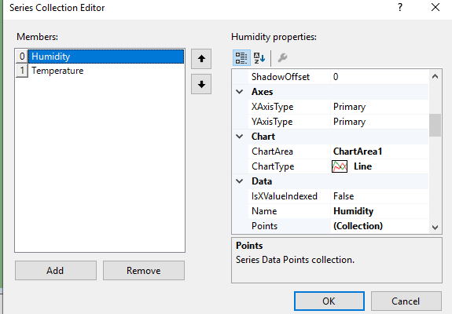

I will now customize the chart so that it could be seen more clearly,at the moment the lines do not seem to be too clear foer the users to see,this is cruicial as the success criteria clearly demands the information to be visible to the user.

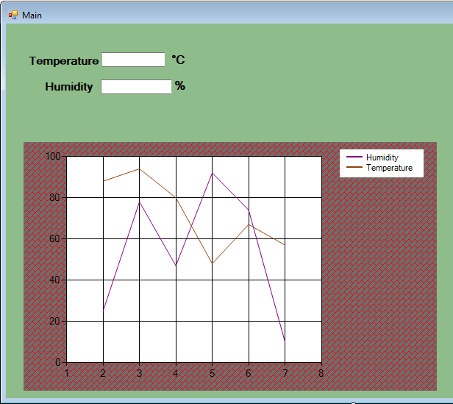

Now I believe the information is clearly visible,colors of Purple(humidity ) and Saddle brown(temperatue) stands out cleraly form the background white. and humidity and the backgrounf of the graph stands out from the rest of the form.

Now that the chart has been designed now I will add the code,I have named the chart as Char_Readings.Adding value to the chart is fairly straightforward and only requires two lines of code.



I have written this code within the Timer1_Tick subroutine.Now that the values have been added on the graph I will run the program to make sure the values are plotted. 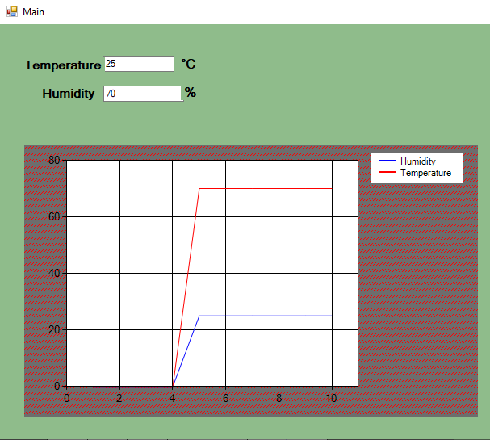

As I expected the graph plotted the live values of temperature and humdiity.

Now that I have received reaigns and produced a live graph from them now I must receive userinput and decide weather or not to warn the user to turn the fan on.

According to the criteria the fan should only be turned on if the actual temperature exeeds a first pre-set value and I have labelled this as primary temperature.

I will add a label and name it primary temperature and since this requires an input I will need to add a textbox as well,I will do this now.

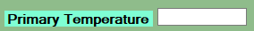

Now I will need to set out some method to let the user know and decide the fan output.Firstly I thought that opening a message box would be ideal however I now decided that using a set of colour changing labels would be more effective,this is because i belive that the users will notice this more,

So I added two labels and named them FAN ON and FAN OFF.



Intially the fan will be off so I will hide the fan on button by changing the colour of the FAN ON button to match the background.I will then program the label so that it changes colour once real time tempearture exeeds Primary temperature.By clicking on the pt textbox I sarted programming.

The following was relatively simple to program after I learned to change the colour of labels from <https://www.daniweb.com/programming/software-development/threads/394338/lable-color-change>

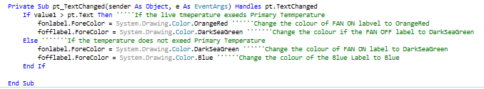

Now I will run the program and try entering a values for primary temperature greater and less than the actual temperature.

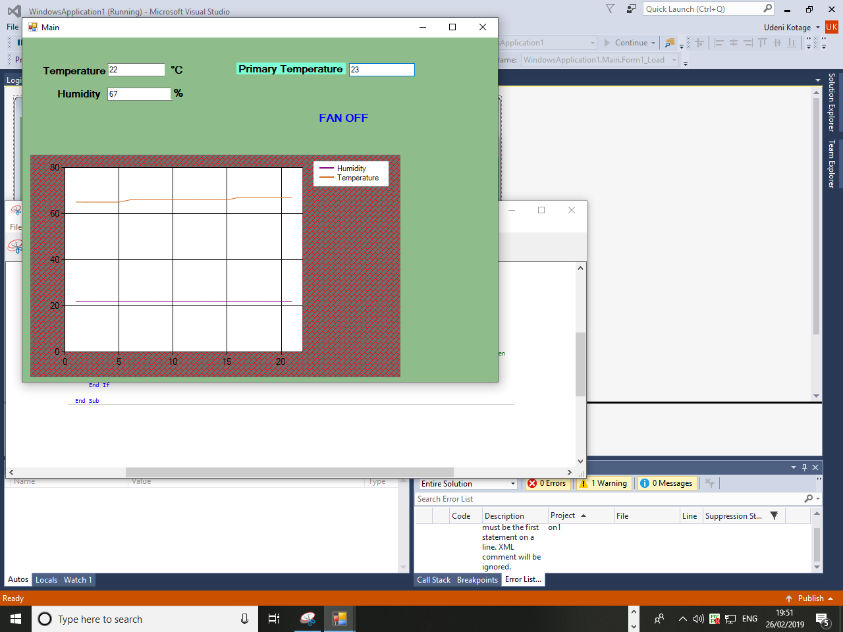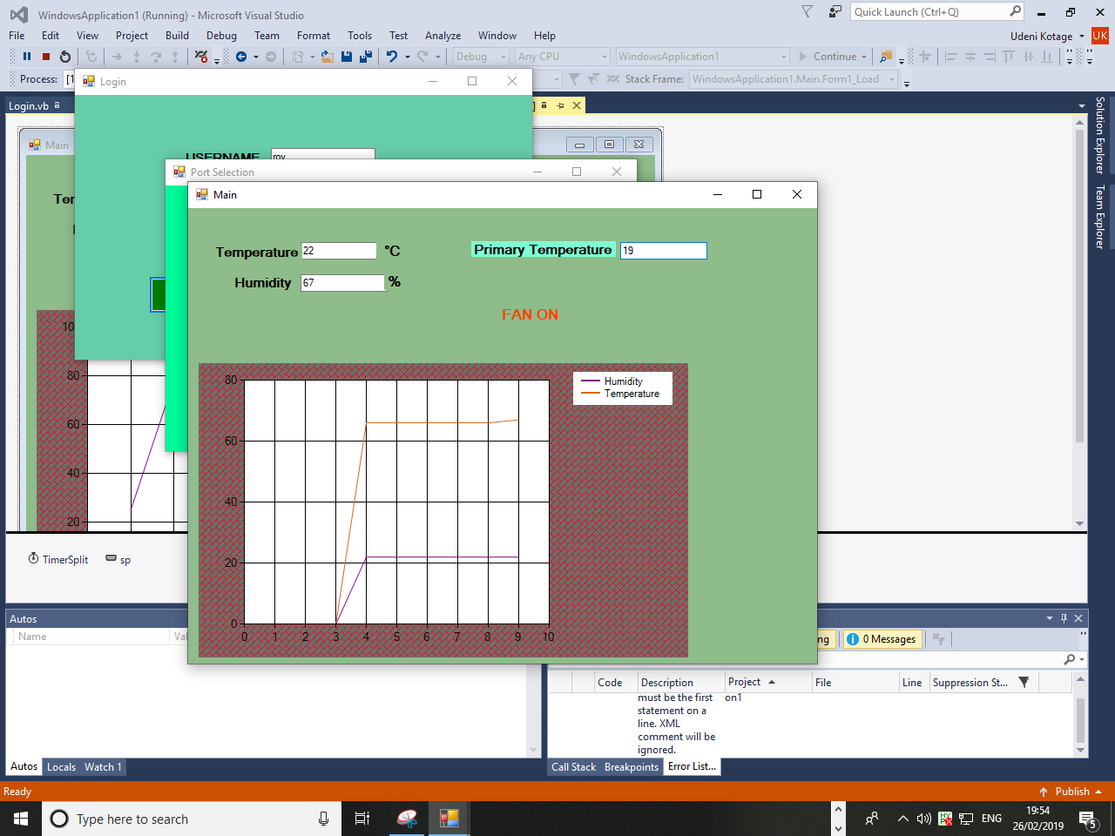When Temeprature > Primary Temperature When Temperature < Primary Temperature

As expected the Users input for primary temperature decided the fan output.I believe that the presentation of the Form could be improved and the data could be made more visible to the user.I will Make the Fan Labels Bigger and the textwithin the Labels Bold and visible,I will use a groupbox to separate the Fan Labels to improve clarity.I will also make the text inside all textboxes larger.

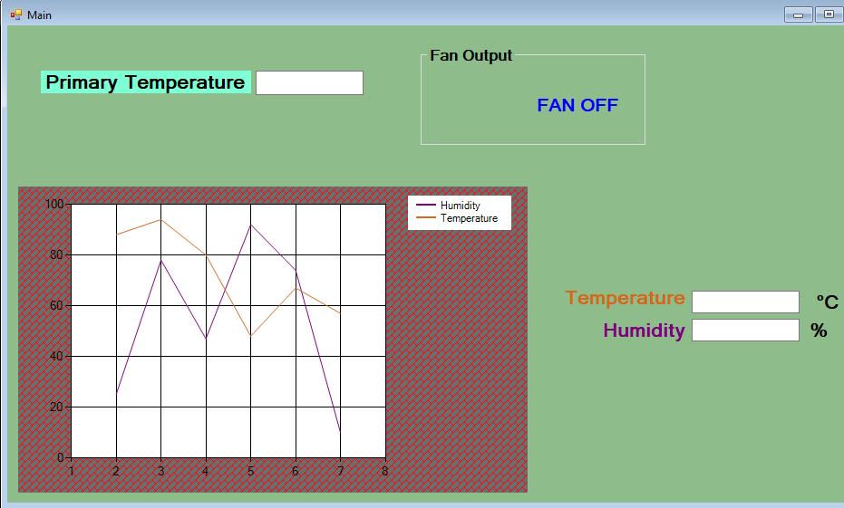

I believe that the clarity of the program is much better after the changes.

My next task is to implement the Visual Output based on the secondary temperature,this will be triggered by an LED connected in my arduino board.So I will visit back to my arduino code in order to start this task.This will be quite troublesome because I currently lack the knowledge to program this is Arduino.

Adter a few searches on the internet I came across <https://electrosome.com> ,by understanding their layout I was able to figure out how to connect the LED to the board.It is a simple connection and no jumper wires are required,however the LED’s have a polarity so that they will only light up if they are connected properly.The long leg of the aruino(Anode) should be connected to the digital pin on the arduino board and the short leg should go to the GND.

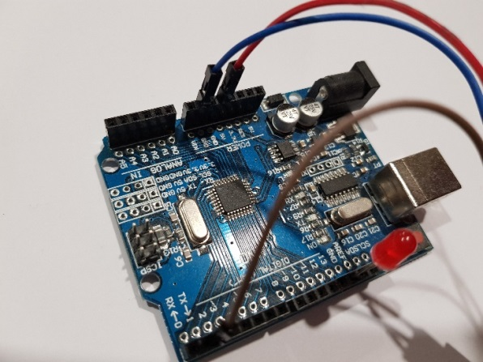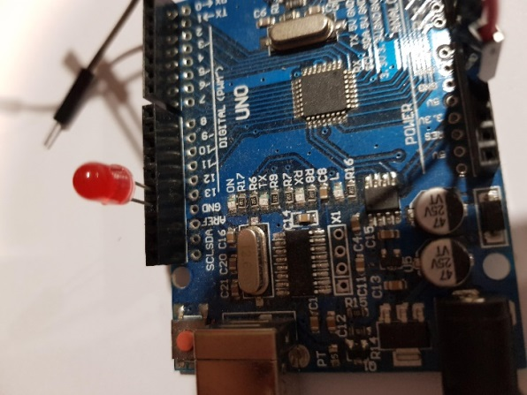

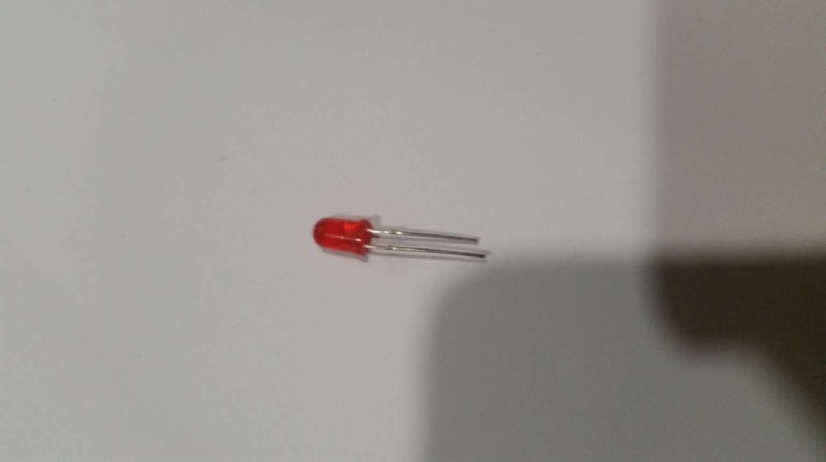

Long Leg (Anode) is connected to the digital pin; in this case i have connected to the digital pin 13.

Short leg(Cathode) is connected to the GND.

Now that I have connetced the LED I will now start the programming.The following websites were extermly helpful

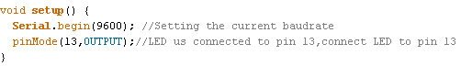

I will start by adding the code pinMode(13,OUTPUT) as a part of the Setup. pinMode() is used to essentially Configure a specified pin to behave either as an input or an output.In my case we cleraly want this to be configured as an output since what I require from the LED is output.

I will the value for the LED with the other values I declared earlier

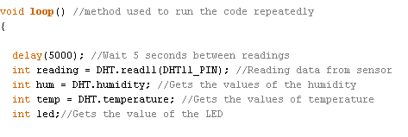

Then I will use the declared value in order to set the condition for the LED output.

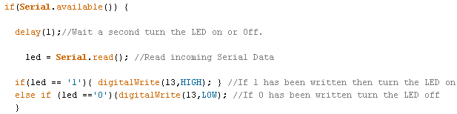

The Serial.Aviable simply retrieves the number of bytes available to read from the serial port.I have made the delay time for blinking the LED very low because it is cruicial that the user is warned instantly,as fast as possible when the secondary temperature is exeeded.Then the arduino reads the serial data(from visual studio).

I learned from <http://www.circuitbasics.com/arduino-basics-controlling-led/> that the arduino switches current on and Off by using HIGH and LOW sinals so when the current is sqitched on it it is called a HIGH sigal,this is is equivalent to one in binary code and alternatively when the current is sqitched off it is called a LOW signals and this is equivalent to zero In binary code.

I soon learned from <https://www.c-sharpcorner.com/article/turning-led-on-and-off-using-buttons-in-visual-studio/> that all that is required from visual basic to turn the LED on is to simply to write ‘1’ to the serial port hence I can base the condition of the LED turning on to depend on this signal from visual basic so when ‘1’ is written to the serial port from visual basic the HIGH sigal can be sent to the aproriate pin connecting the LED which will make the arduino turn the LED ON.

The same but the opposite signal(LOW) can be written to the arduino if the value of ‘0’ is to be written to the serial port.

Now I will return to visual basic to the ‘Main’ from in order to program the serial port.

Returning to visual basic all that was required was to write ‘1’ or ‘0’ to ther serial port after checking weather or not the live temperature exeeded the secondary temperature.I implemented the following code in order to decide the outcome of the LED.

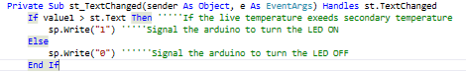

I will now test if this works by running the program and entering the a value for secondary temperature lower than the actual value.

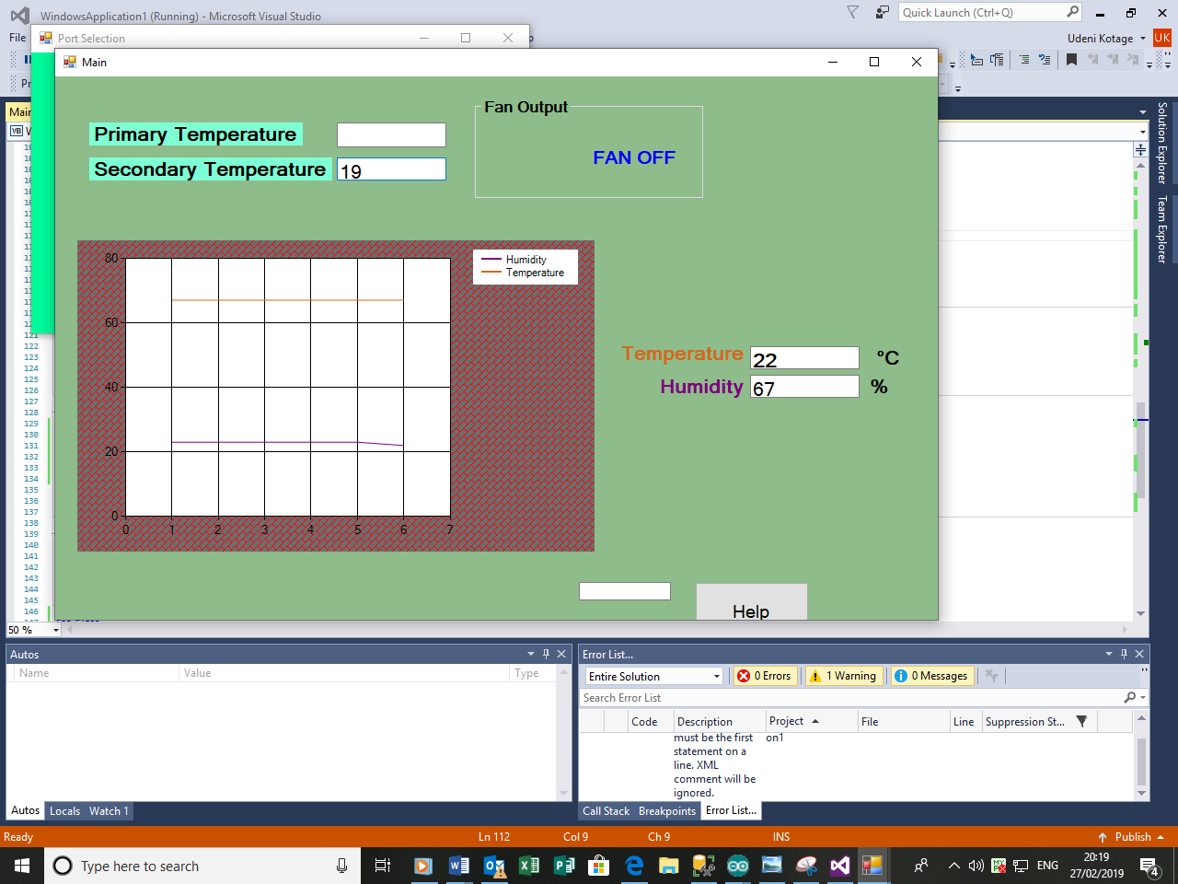

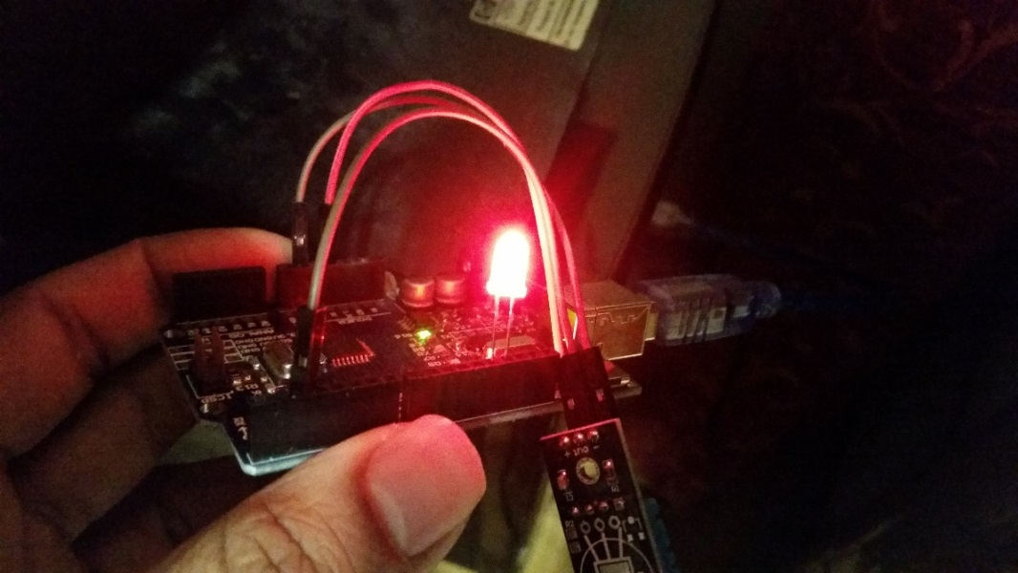

As expected the LED Turned on since the value of 19 which I enterd into the secondary temperature box exeeds the value of the current temperature which is 22.

Now I will run the program again and enter a value for secondary temeprature lower than the current temperature.

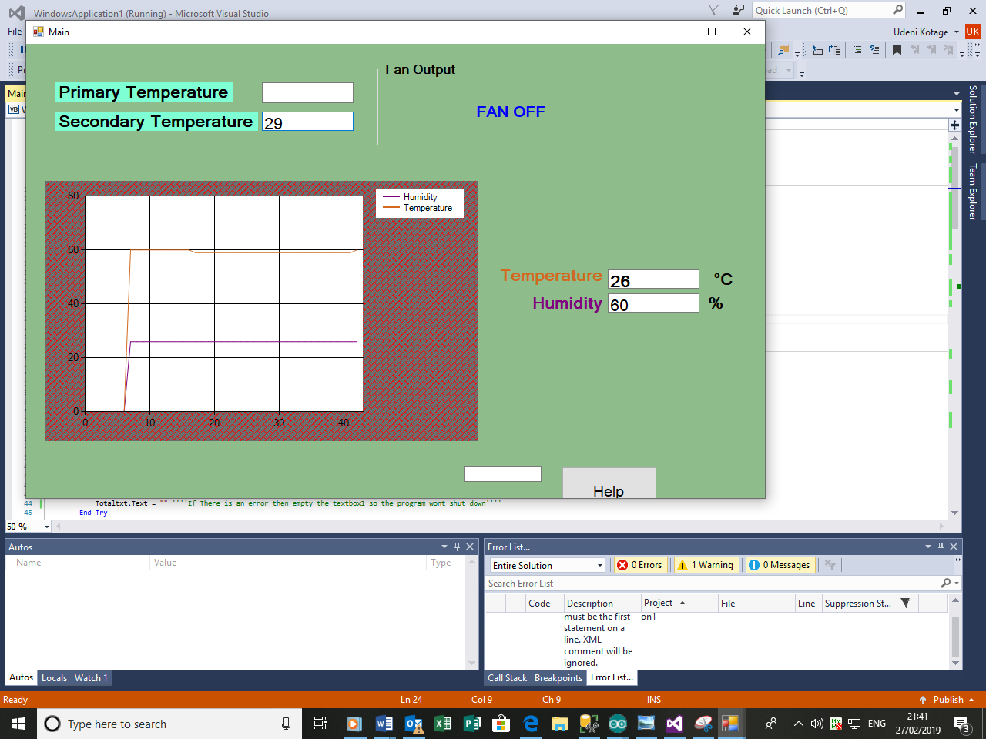

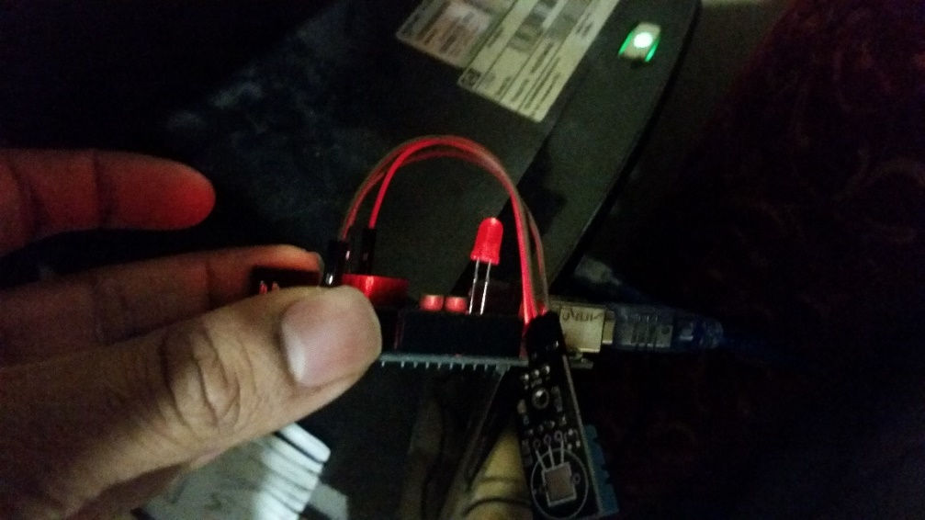

The LED is now turned off since the value of 29 which I entered into secondary temperature textbox is less than the current temperature which has a value of 26.This process of the LED turning on and off is difficult to demonstrate by using pitcures.

As I was running testing the program I noticed something – eventhiugh the live temperature exeeds the secondary temperature the Fan output remains off,this should not be the case because for the visual warning to be triggered priamry temperature must have also been exeeded.So I decided to change the program so the FAN output is also changed if the seconary temperature is exeeded,this should be simple to implement since It requires the same idea as the programming for the primary temperature textbox.

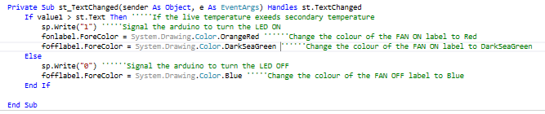

All that I needed to do was change the colour of the the FAN ON and FAN off label.When the secondary temperature is exeeded and the LED light is on,the Fan should not be off so the colour of the fan is changed to orange red to indicate that it should be on.I will now run the program again and enter a value of secondary temperature less than the current temperature to test if the label colour is changed,the LED should be on as well.

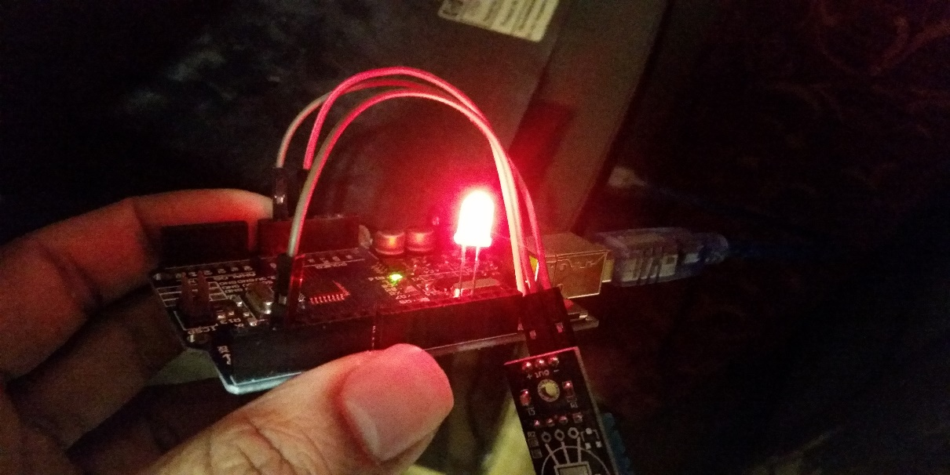

After taking a quick look at the Success criteria I remembered that I am also required to have a warning label alonside the LED if the secondary temperature has been exeeded.Same process I used for the Fan label can be used here but the label needs to be larger.I added yet another label into the form called warning and I named it as warnlabel.I made the text large and Bold.

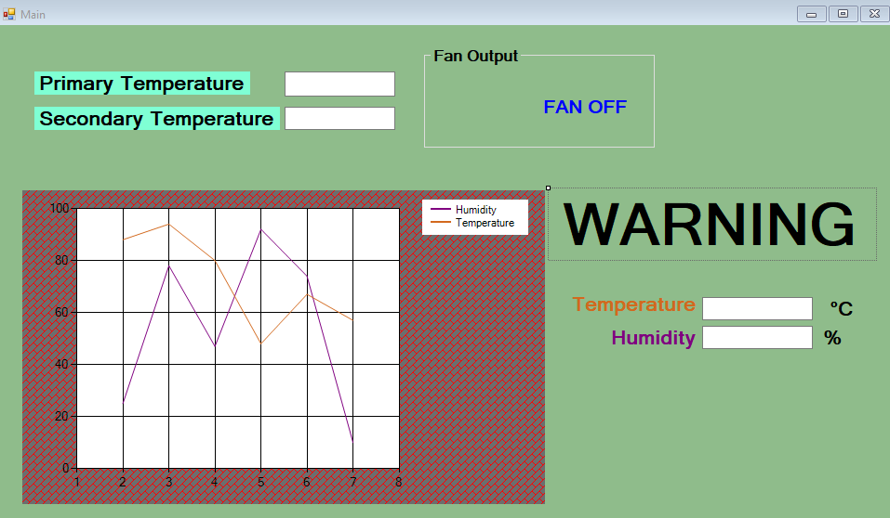

Initially the label will be hidden by having the same colour as the background and once the secondary temperature is exeeded it will be displayed,making it difficult for the user to miss.Hence the coding is the same as previous,this is the code I used.

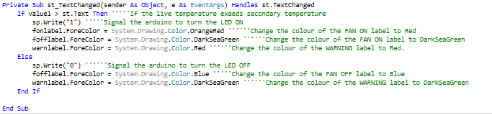

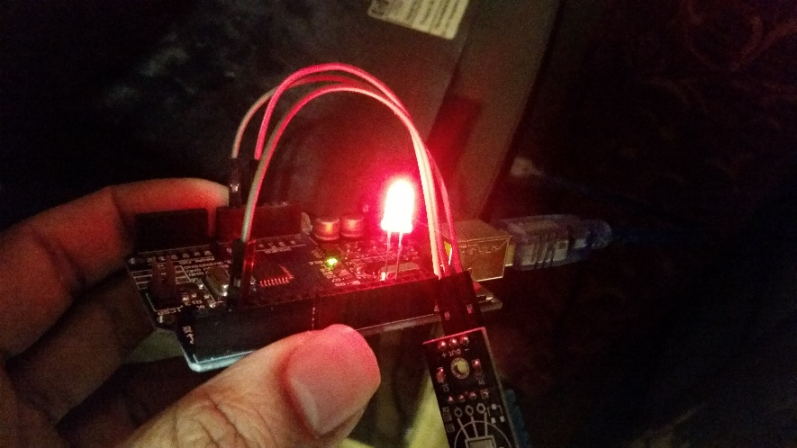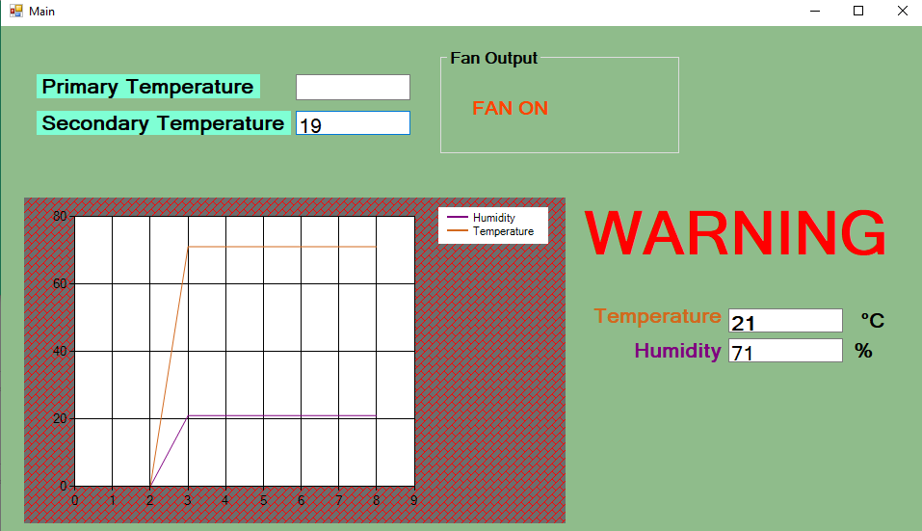I will run the program and make sure the label is displayed if the secondary temperature is exeeded.the LED should be on as well and the fan label should say FAN ON.

Now the user should be well aware if the secondary temperature is exeeded.

The only task left to do of my success criteria is to have a help button which should provide tips on how to interact with the interface.This should be very simple.I will add a button to the form and make sure it is vell visible to the user by making the text bold and the button large.I will name the button as button_help.

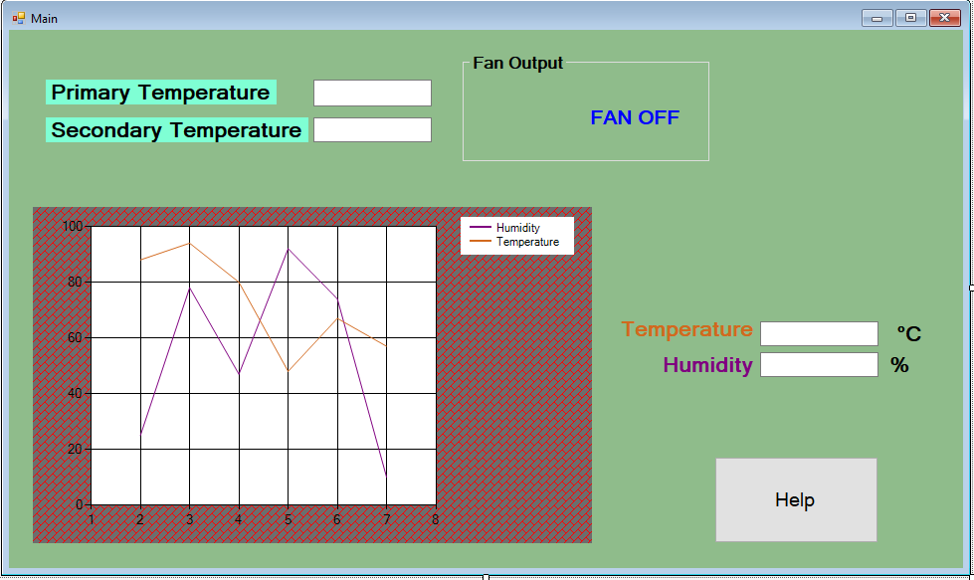

By clicking on the button I programmed the following lines of code with information the user would need to interact with the interface.

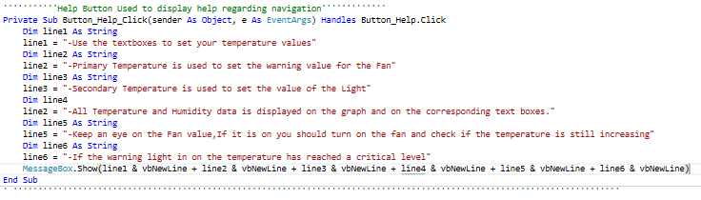

Now I will run the program to check if the above information is displayed when the button is clicked.

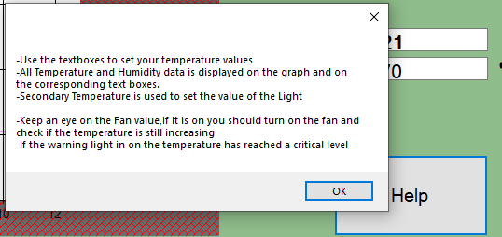

When the button is clicked the information is dispalyed however this is simply not good enough to meet the success criteiria,one of my stakeholders clearly requested everything to be very clear and visible and looking at the screenshot above I can see that the text is very small and lacks quality so I must change this at once.Eventhough I must make improvemetns to this I do not know how to edit a messagebox so I will run a quick google search to find out how.

After searching up information regarding edititng textboxes I found a very helpful youtube video showing me how to do exactly that( <https://youtube.com/watch?v=3cRi8m-rU4Q> ).

From watching the video I realised that I need to add a newwindows form in order to do this.From the main form I will add a new windows form and will name it Helpmsbox.

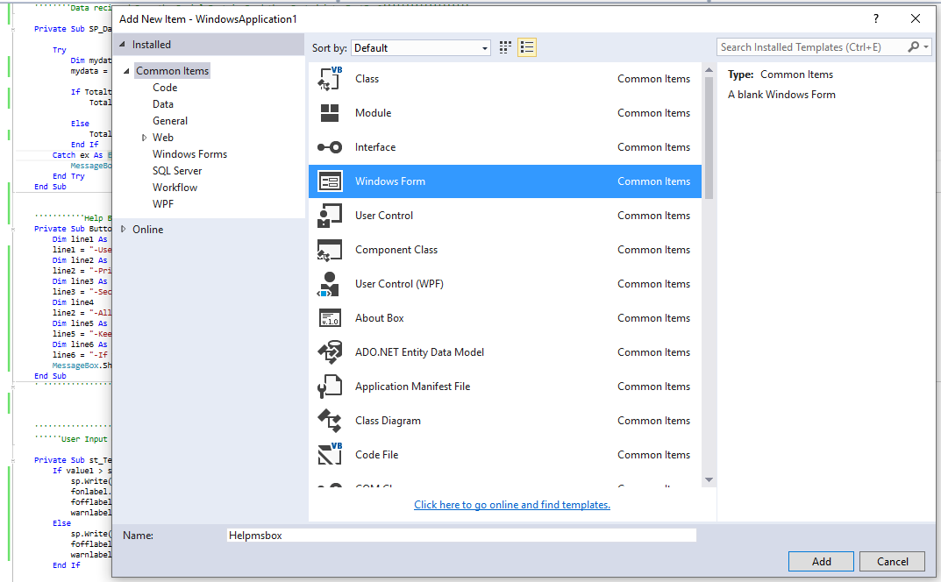

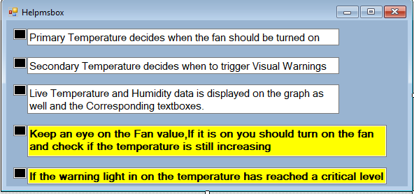I then added the a few textboxes and customised the Form so the Text can be viewed cleraly,the details of the textboxes and etc will not be important because from what ive gathered from the video,this form will not require any programming,it will simply be treated as a messagebox.This is how the form looks after customising it.

Allthat is required now is to return to the main window code and adjust the code for the help button.

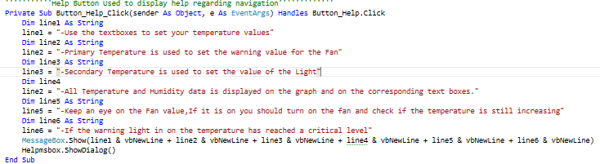

Then I will delete these lines of code and add the following code so that the Helpmsbox is displayed as soon as the button is clicked.This has greatly reduce the lines of code.



Then I will run the program again and click the help button.

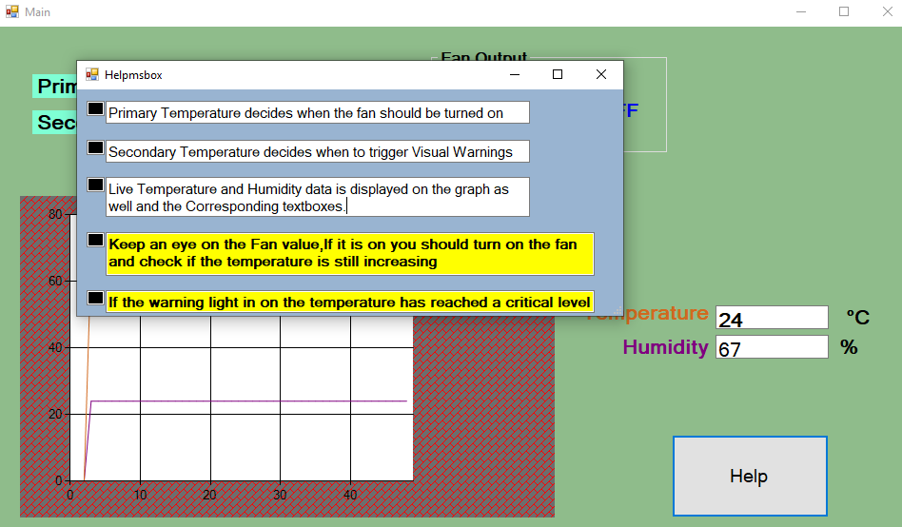

Now that I’ve learnt to customize messageboxes to improve the visibility of the information in them and improve overall presentiation I can now apply this learning to the other two messageboxes I used in this program.

Both of the uncustomized messageboxes belong in the loginform,one textbox opens up when the Login credentials are correct and acess is granted and the other messagebox is displayed when the credentials are incorrect,I will run the program and screenshot both of these messageboxes.

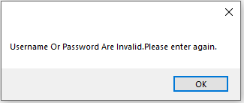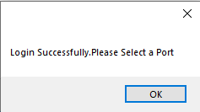

Now I will addanother windows form into the program and call it Validcred.

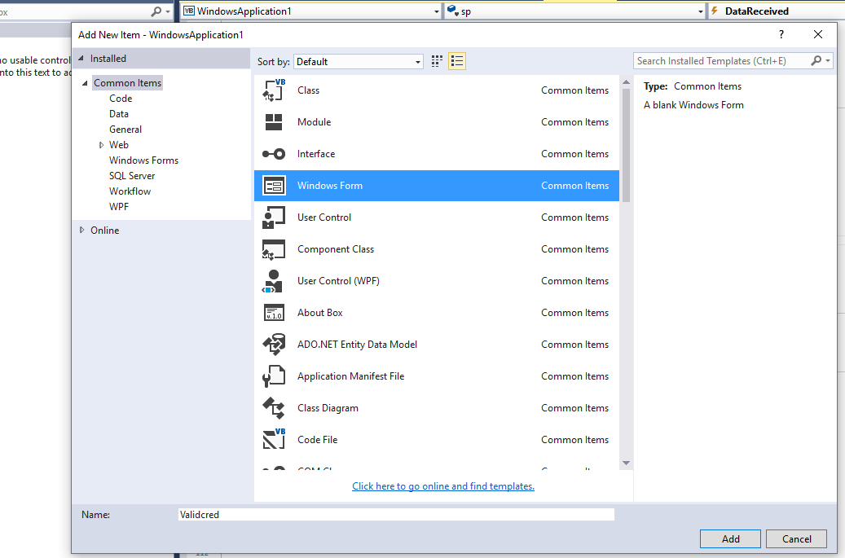

I customised this form by adding making the text as large and bold,I allso changed the background colour then added an image and a button.

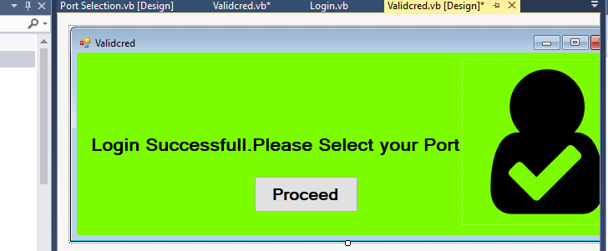

By clicking on the Proceed Button I will need to add the following code so that the user can acess the next Form

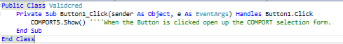

I will now return to the loginform code and open up the code and delete the highlighted line of code.



I will then write the following code instead of the deleted line of code



Now running the program and entering the correct credentials

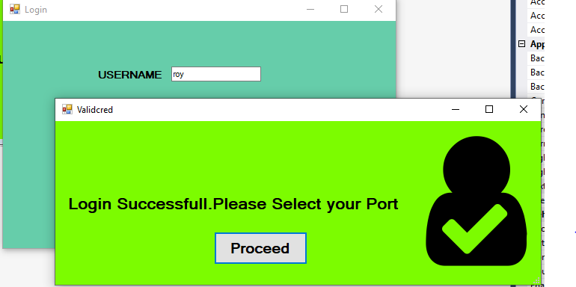

I will then click the proceed button to see if the next form opens up. 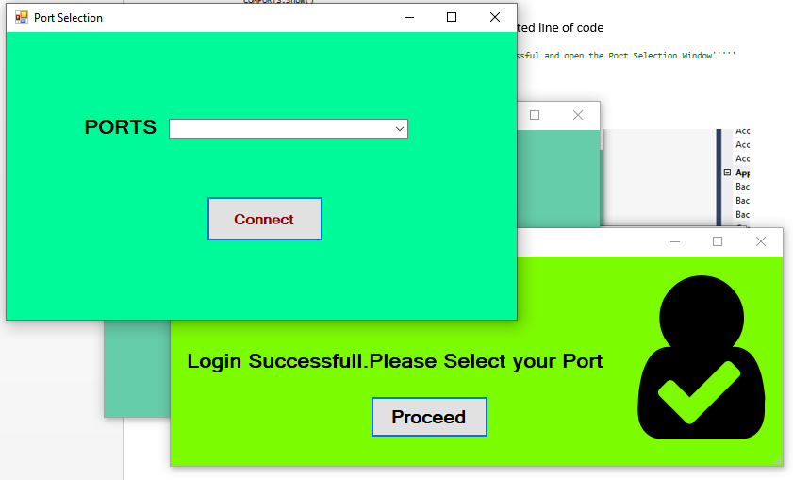

I have manged to receive the expected outcome.Now I will use the same method once more for the messagebox that is displayed when the logincredenials are incorrect.

This requires anotherform so I will addanother windows form and call it InvalidCred.

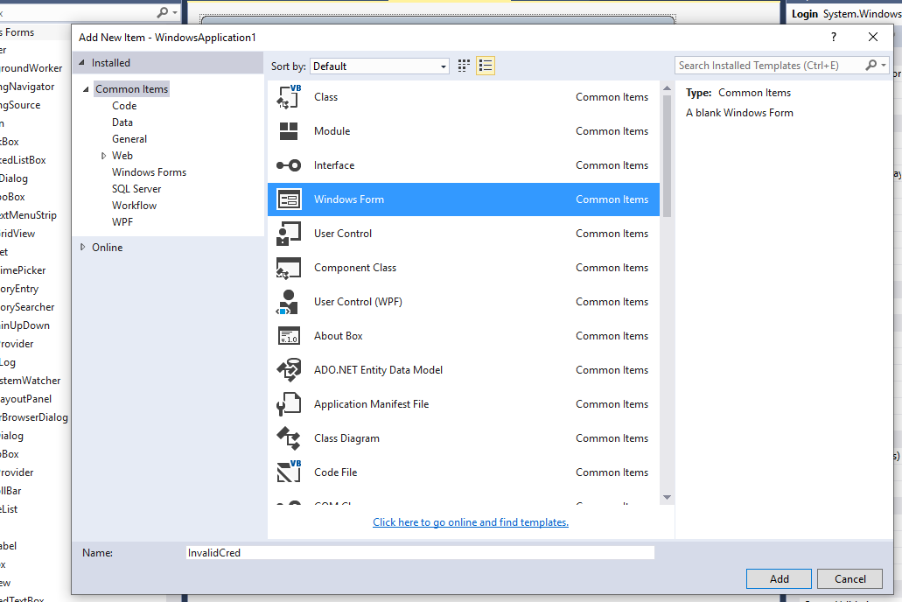

Once more I customised the form by changing the background colour,the size and the font of text and adding an appropriate image.

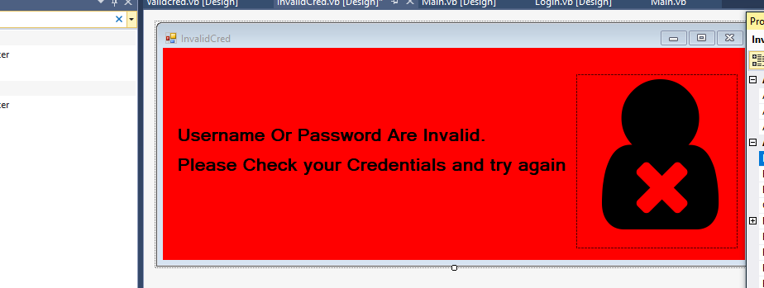

Now I will once again open up the code for the loginform and delete the highleighted code below.



Then replace the deleted code with the code below.



Running the program and entering the incorrect credentials gives

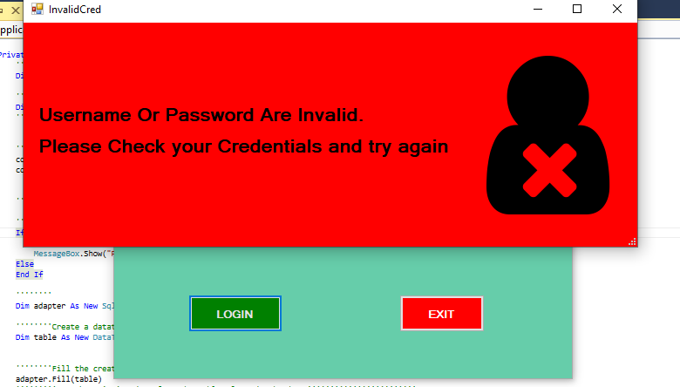

Now that the messageboxes are well customised I will now try to find errors in the systems.

What I will do is try and cause the program to crash so I can identify any errors and fix them to make the system as robust as possible.

I will run the program in from login form to the Main window and feed invalid and extreme data into the textboxes.

First form is the loginform so I opened up the loginform and entered some extreme data into both of the textboxes and clicked the login button.

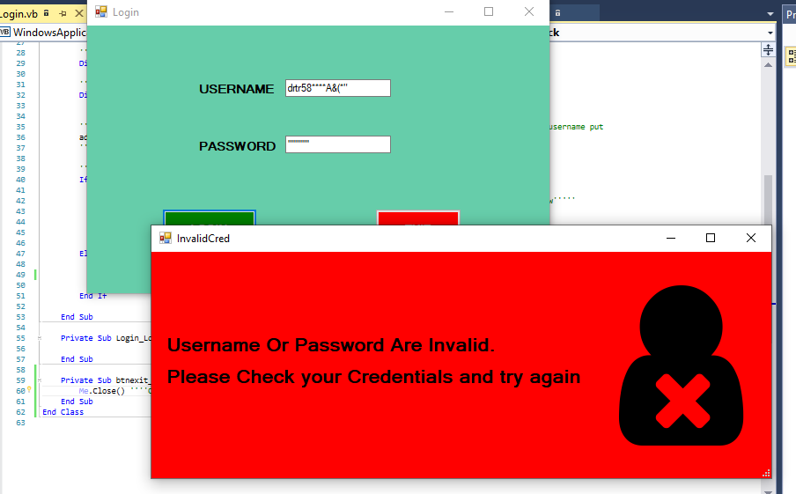

Seems like the loginform handles the extreme data well and do not allow the user into the nextform,does not matter how extreme the data may be the form simply would not accept it unless it equals the credentials stored on the database.

Moving on to the COMPORTS form typed in some extreme data and clicked the connect button.

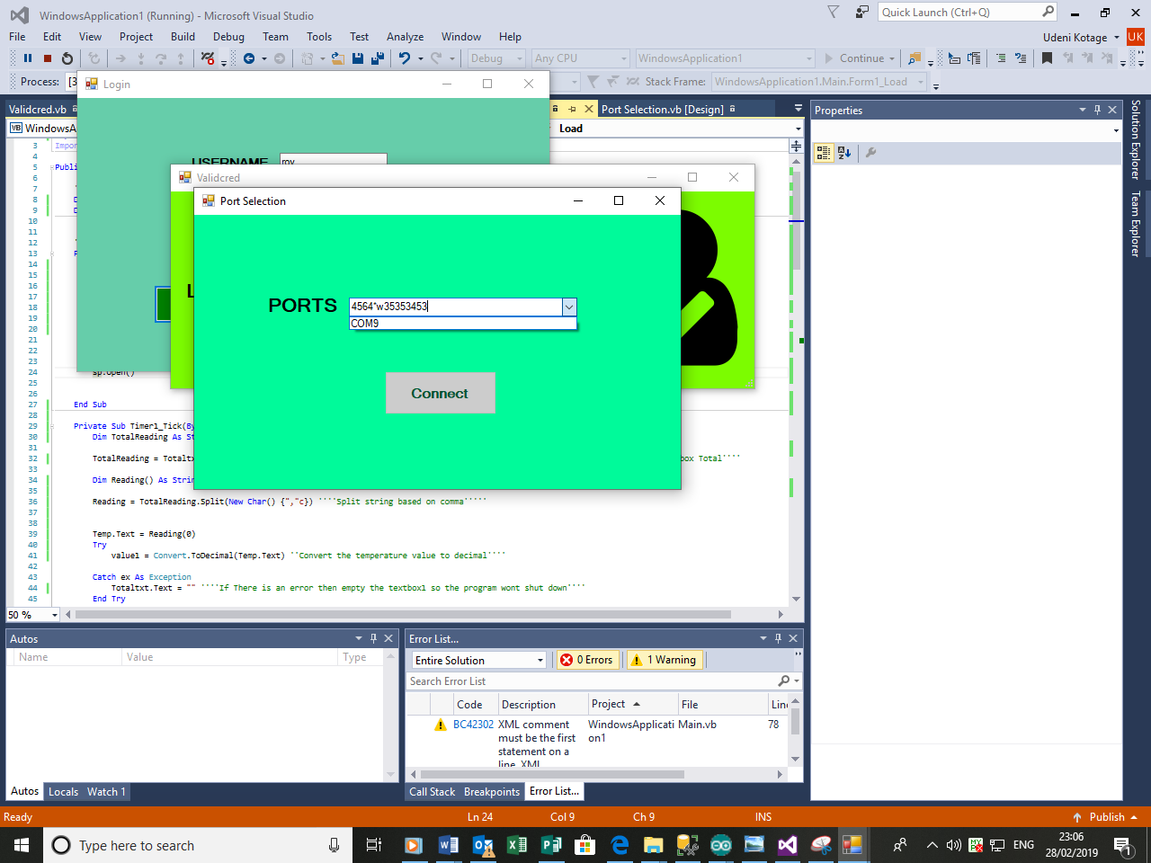

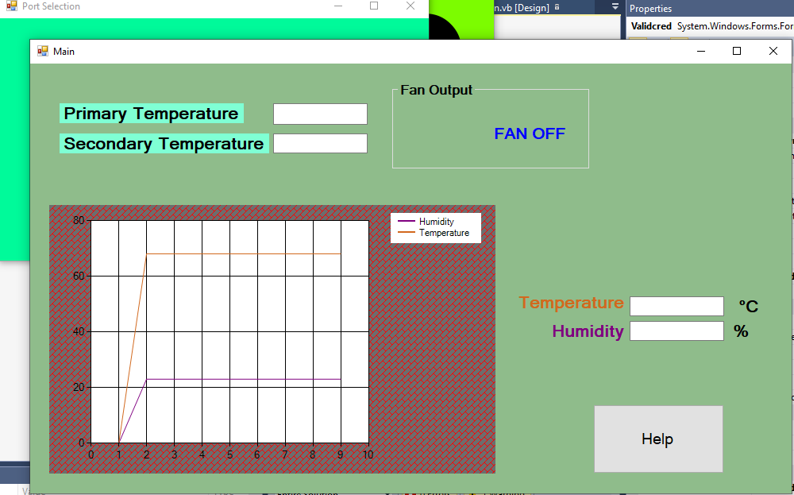

Clicking the comport button with extreme data didn’t seem to make a diffrence because it has identified that there is only one COMPORT listed(COM9) and connected to it.So I will now remove the hardware from the computer and see if will be listed under PORTS,.

Once I connected the hardware the combobox was empty.

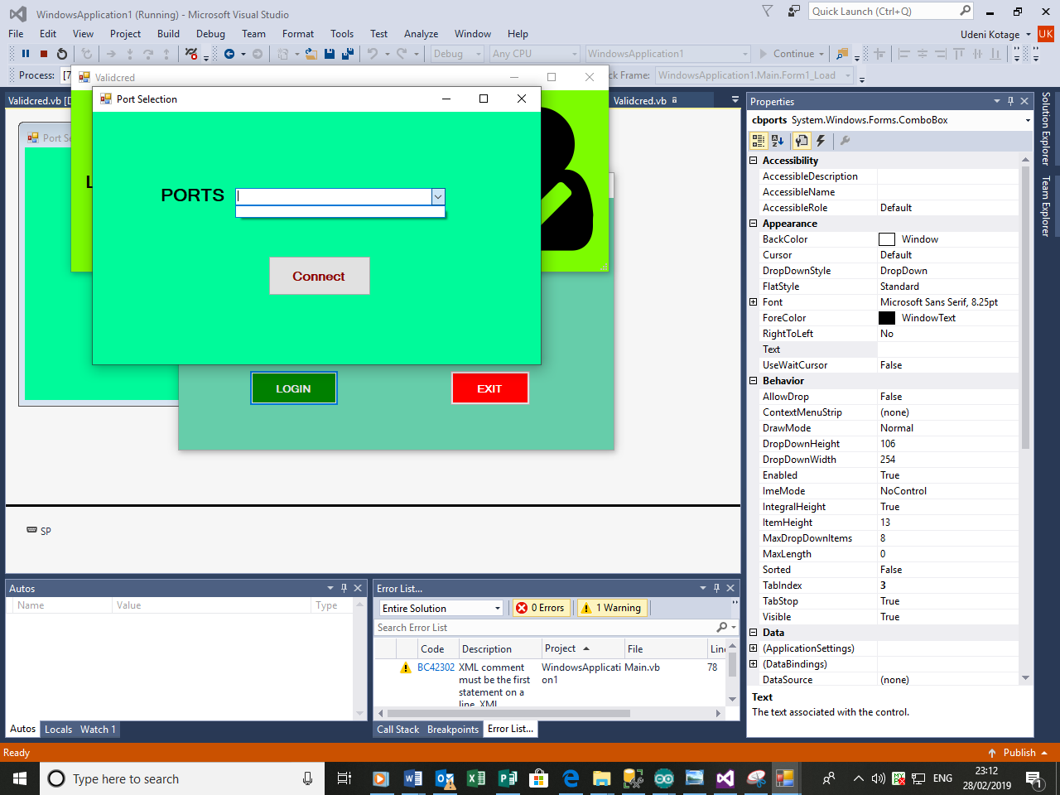

Now I will move onto the MainForm.I will attempt to enter ‘q’ into the textbox that require primary temperature.



The program crahsed almost immediately while displaying the following error

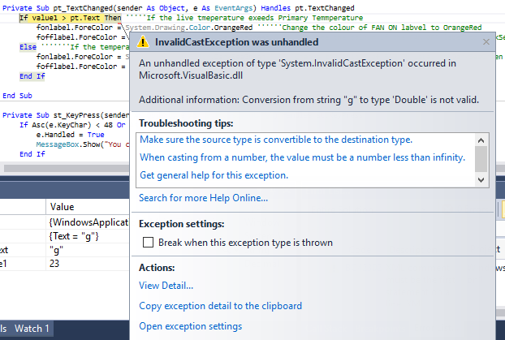

I must understand what System.InvalidCastException is by searching up the error I came across the following website <https://airbrake.io/blog/dotnet-exception-handling/invalidcastexception> this website tells me that this error is caused when I am tryign to convert data from a one data type to another and the type that I am trying to convert into is not supported.Simply put the program is attempting to convert my extreme data into an acceptable type.The error message also confirms this as it states than conversion from string ‘g’ to type’Double’ is not valid.It is actively trying to convert extreme data into processable data which is causing the program to crash.

So I decided that to get around this issue I must validate the textbox,I must put some restrictions into this textbox so that only specific type of data type can be entered,in this case I must make sure that only numerics can be entered as it makes sense for the temperature to be entered as a numeric instead of a word.

In order to do this I will need to use a ‘Key press event’ which is an event that occurs as soon as a user presses a key that produces a typable chracter on a running form so by clicking on the top right hand dropdown list I can acess the key press event for this textbox.

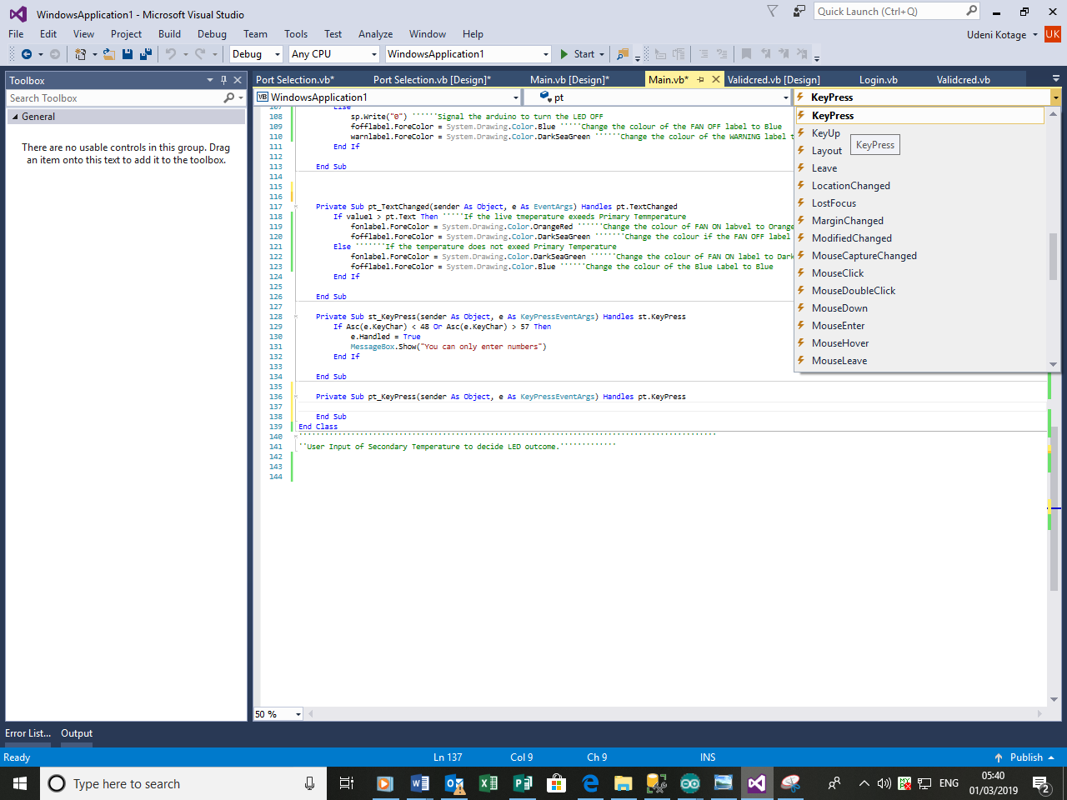

Once clicked it opens up the following Event handler



Now I will use the following code in order to ensure that only numeric input can be enterd into the textbox.



Essentially the e.KeyChar tells the character which is pressed. “<> 8 = Less than or more than 8” allows backspace key to be pressed. In ASCII, 48 indicates 0 and 57 indicates 9. Inbetween 48 and 57, there are numbers.Visual basic checks if the entretd chatacher is a number or not,if its not a number it displays a message and asks the user to enter input again.

Now I will run the program and attempt to enter extreme data into the primary temperature textbox.

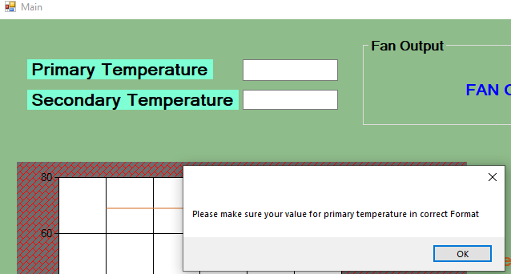

Now the textbox can handle extreme data well and it simply do not accept any input other than a number.

Now before I enter extreme data into the secondary temperature textbox it is fairly obvious the same error would be occurred because I have not validated the textbox for secondary temperature input either so I will do this now.

I can use the same event I used to validate input for primary temperature so I will click on the textbox to acess the editor and open up another key press event by navigating to the dropdown list on the top right hand side of the editor and program accordingly.The code below is the code I used.

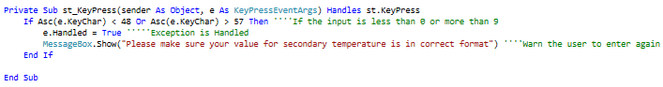

Now I will run the simulator and attempt to enter extreme data just to confirm that it will be ignored and asked to enter again.

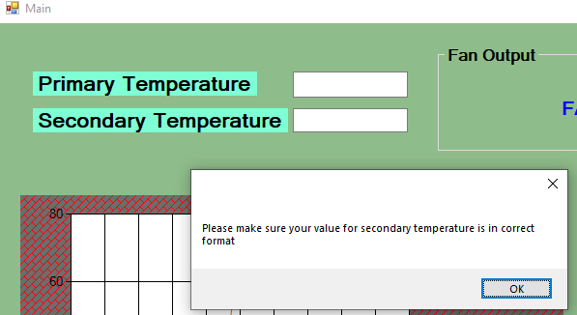

As expected extreme data is ignored and asked to enter again in suitable format.

Stakeholder Testing

Now that my program is robust and has met the requrimets set out by the stakeholders.I met up with each of the stakeholders so they can test my final program.I later emailed them the following questions to receive feedback.

Mr Kumarswarmy

**Did you have trouble when navigating the program?**

“Not really,the interface was well designed and was easy to undestand,I like how you made sure only numbers can be put into the Temperature textboxes,though the messagebox that shows up after i put in the wrong values had very small text”

**Did you have trouble reading the text in any of the forms?**

“Not at all everything was large and clear enough for me to see.I like the choice of background colours because It really makes the text stand out.”

**Did you use the help button?**

“Yes the help button was very useful because the information it gives is useful.I like how you highlighted the critical pieces of information so they stand out.”

Mr Gray

**What did you think of the LED feature?**

“The LED feature was impressive and it reacted quickly and turned on when I made the temperature critical.If the same idea was used in a real system It could prevent disasters.”

**Does the graph help with visualising the changes in temperature and humididity?**

“Yes the graph was very helpful and I think that having the textboxes with the live readings near the graph was definetly a good Idea and the graph help compare the recent values to the ones before.”

**Do you think that the sensor I used was suitable?(Mr gray tested the accuracy of the sensor by comparing the readings with another senor he had built into his watch)**

Yes the sensor is very accurate and when I compared it with the one in my watch it was almost identical so we can say that It works very well.

# Review

To summarise the stakeholder feedback I believe that the system is up to the standard the stakeholders expected only critic I received is because I had ignored the textbox that warns the user when extreme data is inputted into primary and secondary Temperature however I belive that this can be easily read anyway and by common sense the users should be able to figure out why they receive the error message in the first place.

|  |  |  |  |  |  |
| --- | --- | --- | --- | --- | --- |
| Test ID  ]  Arduino  Visual Basic | Test Objective | Inputs/Actions taken | Expected output  Testing | Actual Output | Reason for testing |
| 1 | Check If the username and password ignored and asked to enter again if it is not equal to a one stored in database? | Input 180321 and check if error is displayed | Display error message and ask to enter the username again | As expected | This will ensure that the user input is compared against database values to decide whether or not to grant further access. |
| 2 | Check if next page displayed when the credentials are correct and the login button is pressed? | Click the Login Button after entering valid Credentials. | Open the Port Selection page | As expected | This will make sure that the user is given access to the program if the credentials are valid. |
| 3 | Check if clicking the exit button closes the form. | Click the exit button. | Close the form. | As expected | This will make sure that users can exit now if they do not wish to see the program. |
| 4 | Check if the hardware will show up on the selection if it is not connected | Disconnect the Arduino from the computer then attempt to connect to the port. | Do not display the disconnected hardware on the dropdown box | As expected | This is a check to ensure that by this point all the hardware is connected properly. |
| 5 | Try to see if sensor values are received without connecting hardware | Disconnect the Arduino from the computer and try compiling the program | Do not receive any readings | As expected | This will be yet another check to ensure that all hardware should be connected properly. |
| 6 | Try to see if  Sensor values are received by connecting the hardware but disconnecting the sensors | Disconnect the sensors from the board but keep the hardware connected to the computer. | Do not receive any readings | Not as expected but displays the correct message to the user. | A check to ensure that the sensors are connected/calibrated properly. |
| 7 | Try to see if increasing the temperature causes the received values to increase | Use a cup of hot coffee and place near the sensor to allow the sensor to read this | Temperature should increase | As expected | To ensure that the sensor works as expected and can detect a rise temperature |
| 8 | Try to see if decreasing the temperature causes the received values to decrease. | Use an ice pack and place near the sensor to allow the sensor to read this. | Temperature should decrease | As expected | To ensure that the sensor works as expected and it can detect a fall temperature |
| 9 | Check if the system was able produce a graphical chart of live temperature and humidity | Check if the chart has been produced | Produce a graphical; chart displaying real time temperature and humidity | As expected | To make sure the user can view trends temperature and humidity. |
| 10 | To see what happens when text is entered into Primary temperature box | Enter “Hello” into the primary Temperature Textbox | Program to ignore text, displays message and asks for input again. | Error caused due to poor validation initially but fixed later. | To make sure that the user’s input for Primary Temperature is in a valid (integer) format. |
| 11 | To see what happens when text is entered into Secondary temperature box | Enter “” into the Secondary Temperature Textbox | Program to ignore text, displays message and asks for input again. | Same error to Test 9 hence same fix was applicable. | To make sure that the user’s input for Secondary Temperature is in a valid (integer) format. |
| 12 | To see if the Fan turn on when Primary temperature is exceeded? | Input a primary temperature greater than the current reading  Expect a warning label. | Program alerts the user than the fan is turned on. | As expected | To make sure that the user is able to adjust the temperature which can cause the fan to turn on. |
| 13 | To see if the LED turn on if the live temperature is greater than secondary temperature | Input a primary temperature greater than the current reading  Expect the LED to turn on. | Program writes to Arduino allowing LED to turn on. | As expected | To make sure that the user is well warned if the temperature reached extreme levels and they are able to adjust the temperature that triggers this warning. |
| 14 | To see if the help button displays information regarding interface navigation. | Click the help button | Program displays instructions on how to navigate the program. | As expected | To ensure the users have sufficient knowledge on how to navigate the interface |
| 15 | Is the Warning Displayed clearly if the live temperature is greater than secondary temperature | Input a Secondary temperature greater than the current reading  Expect a warning label. | Program changes the colour of the camouflaged warning Label to Red. | As expected | To ensure that the hardware list is refreshed to make sure that the correct hardware device shows up on the screen. |

Test1:

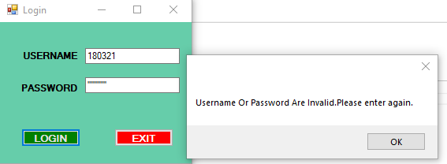

The test has passed as expected and the apropriate message was dispalyed,restricting acess.

Test 2:

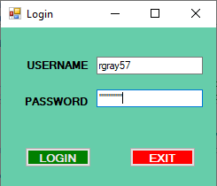

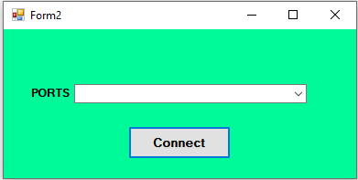

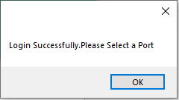

As expected the Ports window was open if credentials are correct. The test has passed.

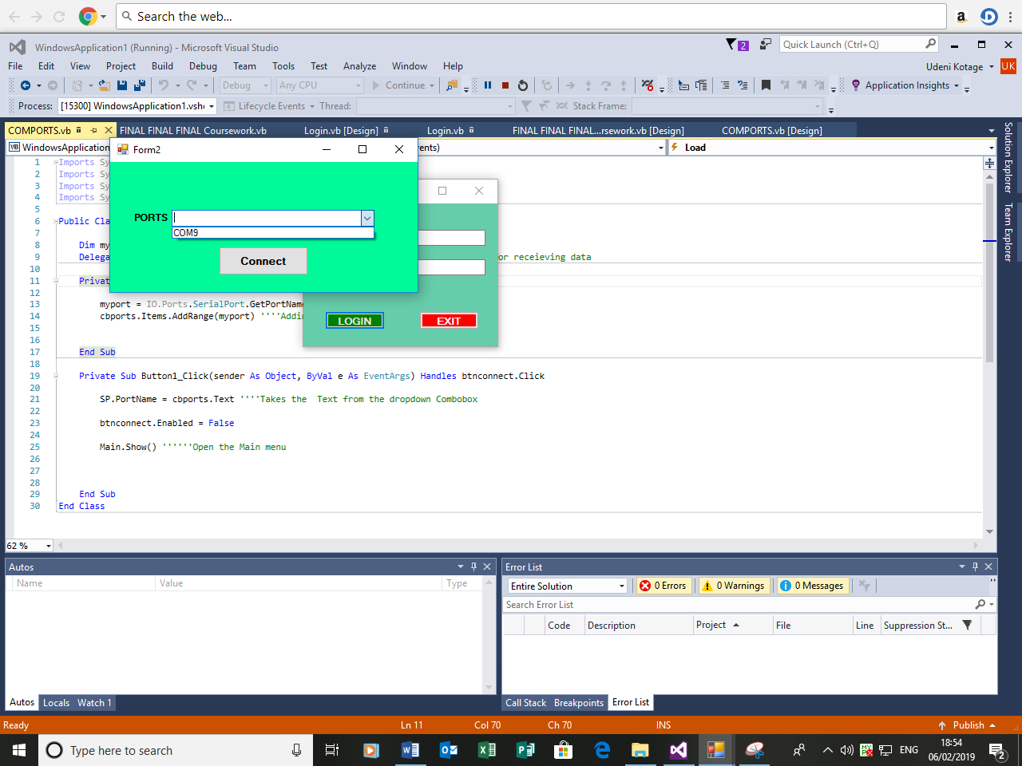 Test 3:

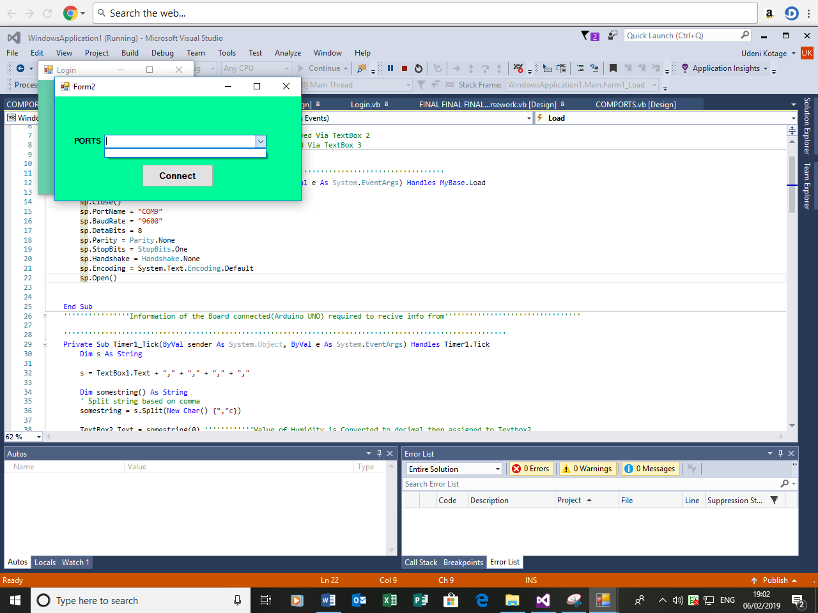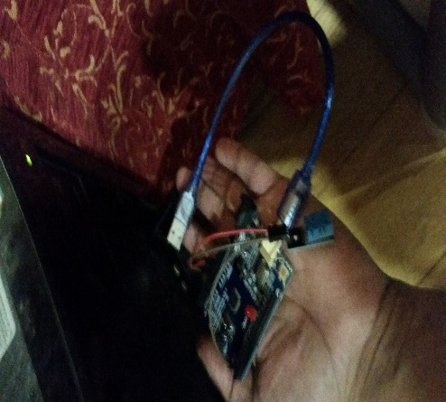

The test has passed and as expected the COMPORT is not listed once hardware is disconnected.

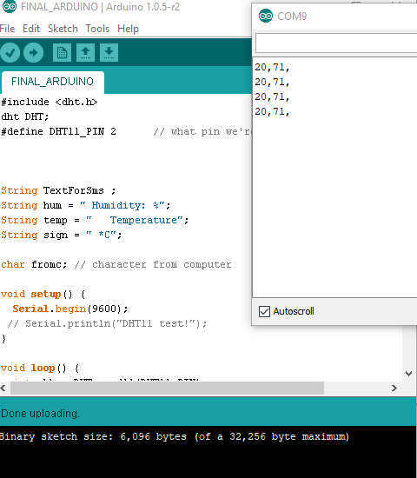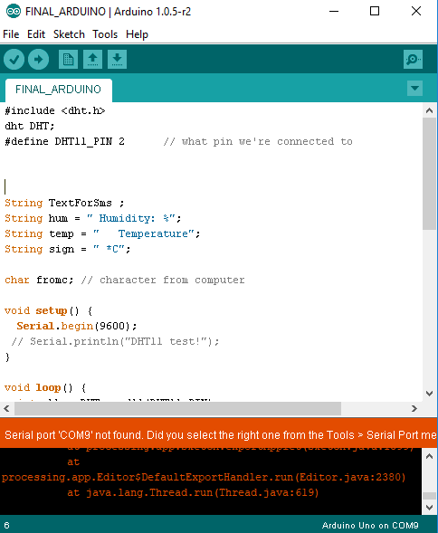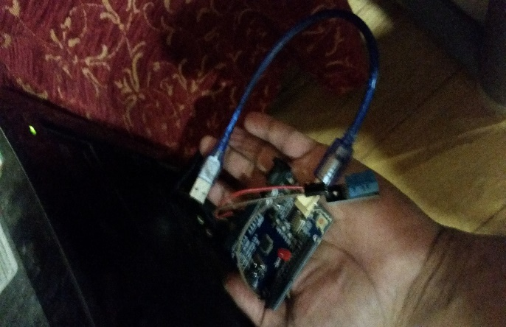 Test 4:



Test Passed as the readings fail to be received as the code cannot be uploaded once the hardware is disconnected.

Test 5:

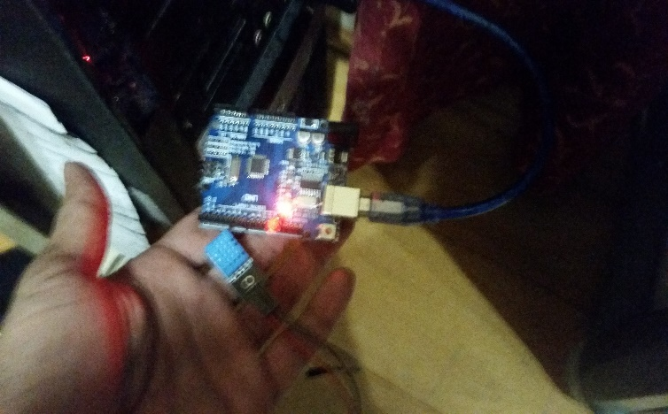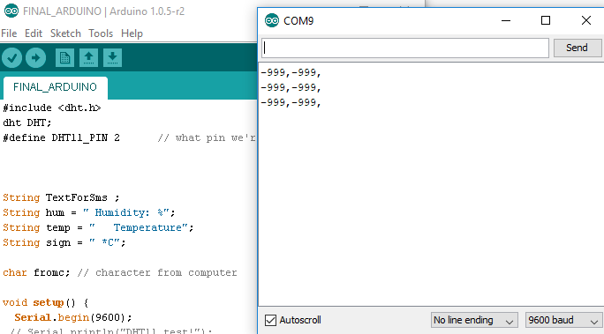

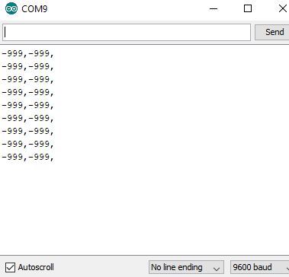

Extreme readings are shown once the sensor is disconnected from the hardware, this indicates that the sensor must be checked. Even though this differs from the expected outcome, we can assume that a similar action is required.

Test 6:

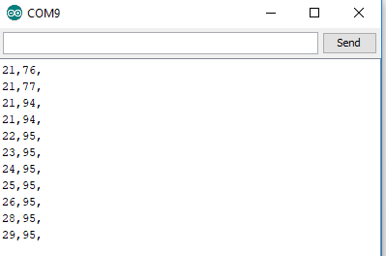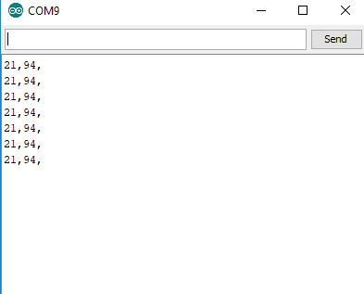

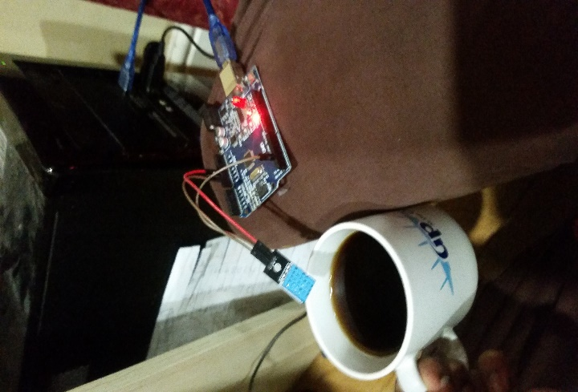

As expected temperature increased once the sensor is exposed to hot coffee. The Test has passed.

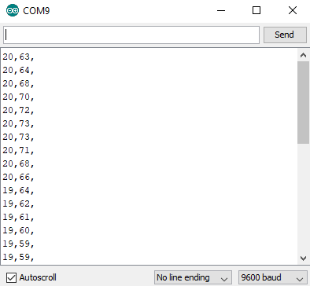 Test 7:

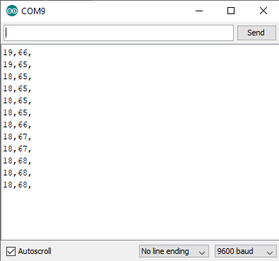

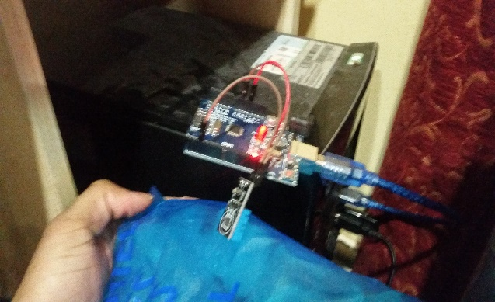

Test has passed as the temperature decreased once the sensor is placed near a pack of Ice.

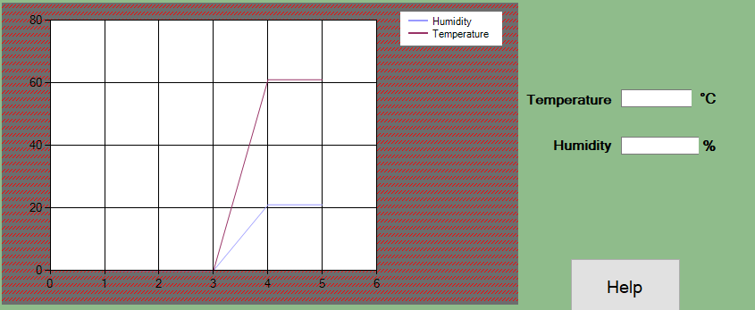 Test 8:

The test has passed a live graph for temperature and humidity values are displayed.

Test 9:

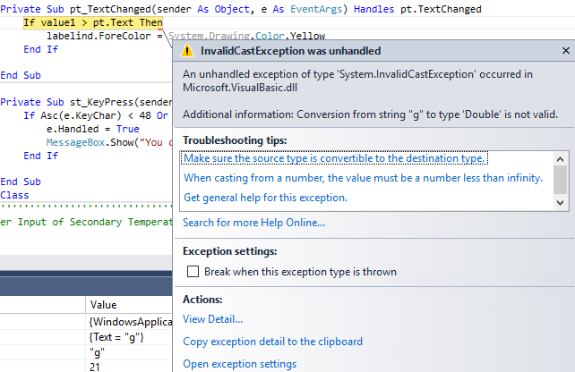When I attempted to enter a letter for the value of primary temperature the program did not pass as I initially expected due to the following error, which caused the program to crash. At this point I realised that I have not validated this textbox.



The error expected test due to an caused by error in the conversion from string to double after searching up this error I realised that I should use the following event handler to apply restrictions to the text boxes so that nothing else can be inputted in except numerical values.

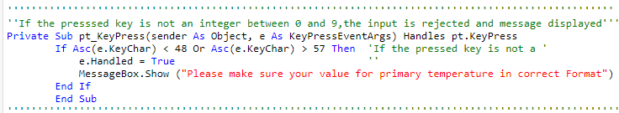

The Key Press event is initiated when the user presses a key that produces a typeable character on a running form.

-e.KeyChar identifies the character which is pressed.

-In ASCII, 48 specifies 0 and 57 indicates 9. Characters in between 48 and 57 represent numbers.

By Using ASCII the event handler checks if the entered character is number or not. If it is number, it is allowed to be printed.

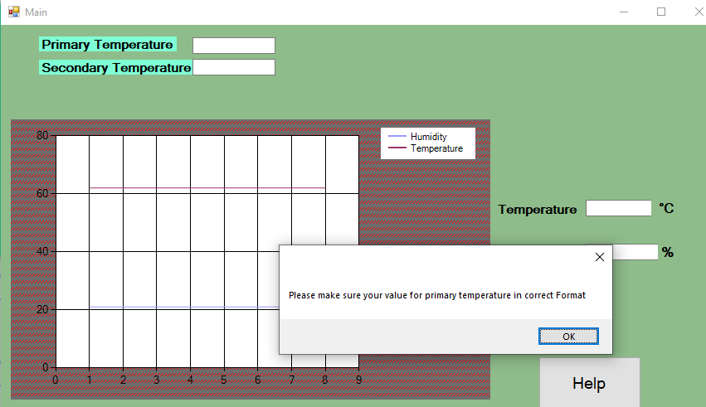

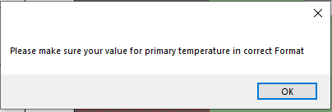



After the adjustment was made I was able to receive the desired outcome. Test has now passed.

Test 10:



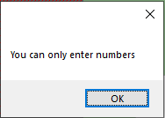

I applied the same event handler I used in method 9 in order to successfully validate the value for secondary Temperature. The desired outcome was received hence the test has passed.

Test 11:

Initially fan is off given that initial temperature is less than the Primary temperature.

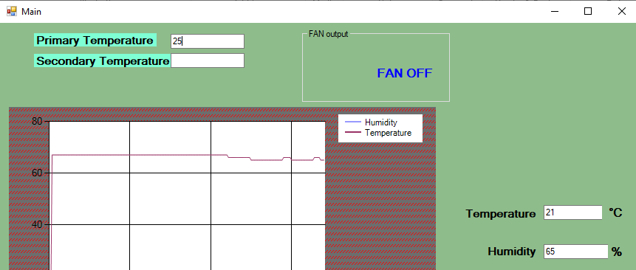

After inputting 12 for the value of Primary Temperature so Primary temperature > Temperature

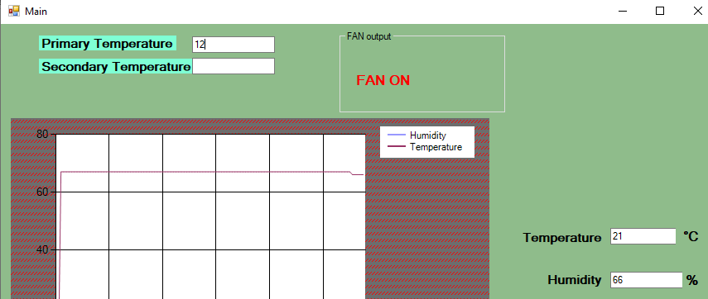

As expected the test has passed.

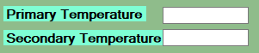 Test 12

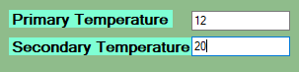

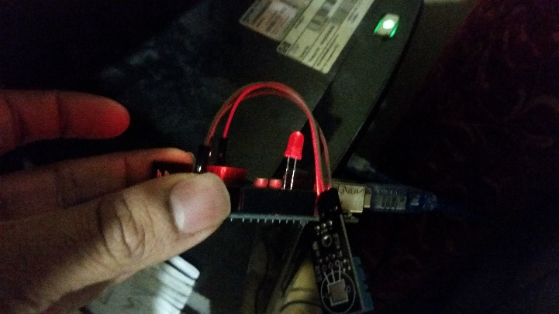

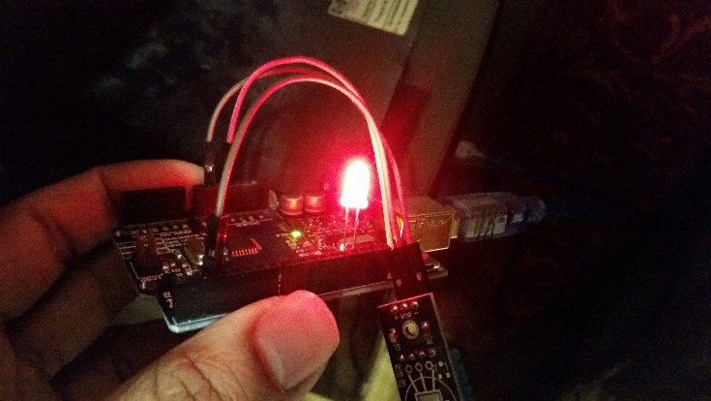

The test has passed as the LED did turn on once the value of secondary temperature was exceeded.

Test 13

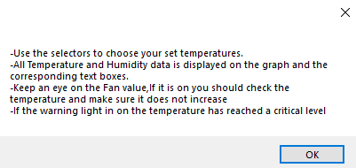

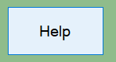

As expected help is displayed for the user’s convenience, Test has passed.

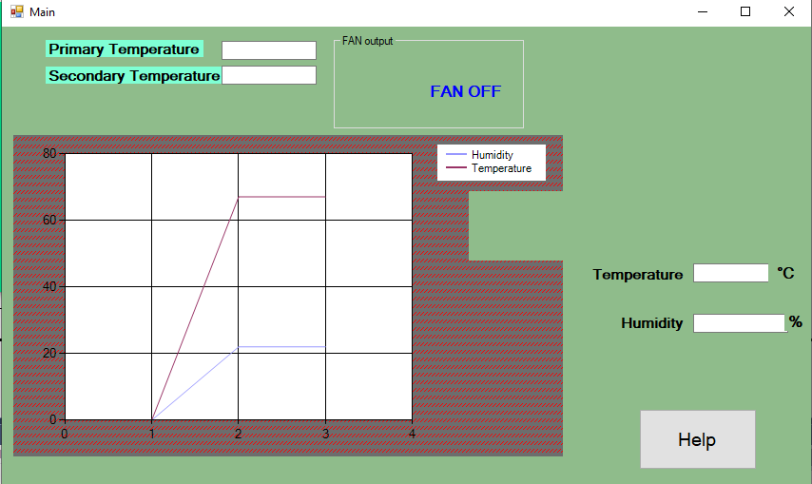 Test 13

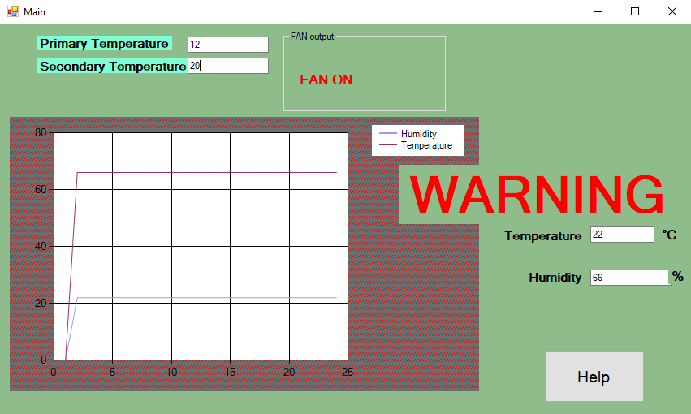When the value for secondary temperature is greater than the current temperature, displays the hidden warning.

Expected outcome is received, Test has passed.

## Evaluation

To evaluate the project I need to revisit my initial success criteria and compare my end result with it to check if I have met the requirements .The table below summarises my initial success criteria and whether or not I have met them.

|  |  |
| --- | --- |
| Criteria | Is the criteria met? |
| Receive Real Time Temperature and Humidity Values via sensor and allow the user to view them | Yes. |
| Allow the user to set a value to determine Fan Output, if live temperature exceeds this value let the user know the fan should be on. | Yes |
| Allow the user to a set value to determine the output of a warning light, if live temperature exceeds this value then trigger the warning light. | Yes |
| Display a warning to alert the user when temperature reaches a critical value. | Yes |
| Make sure the design is user friendly, simple and have large enough text for users with weak eyesight. | Yes |
| Offer the user help with navigating the system | Yes |
| Produce a Live chart showing live temperature and humidity readings. | Yes |

I will now provide evidence to prove the criteria has been met

* Receive Real Time Temperature and Humidity Values via sensor

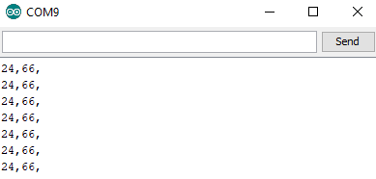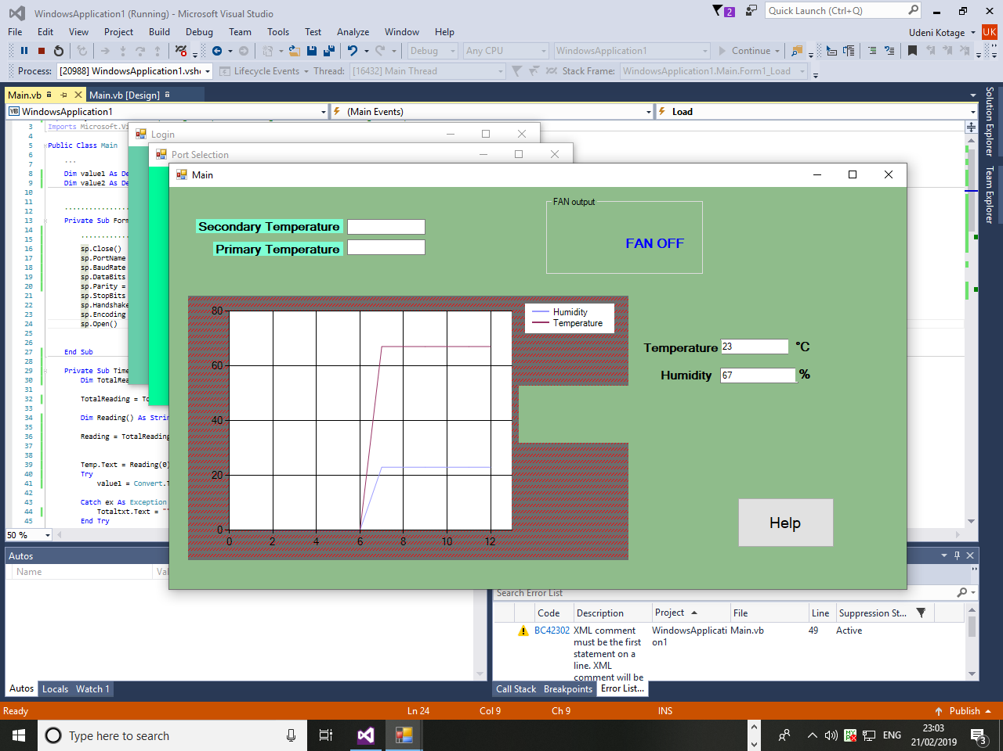

You can view the live temperature and humidity values and they are updated every five seconds

The system has met this criteria because the program displays genuine real time temperature and humidity values I have tested that the sensor Is how the temperature reading changes by testing the sensor with a hot cup of coffee and an ice pack (Refer Test ID 8 on the test table).

* Allow the user to set a value to determine Fan Output, if live temperature exceeds this value let the user know the fan should be on.

The system has met the following criteria because the program has used labels which change in colour if a set temperature (Primary Temperature) has been exceeded. If the Fan should be on then the program makes sure that the user can clearly see that the FAN ON label, which is initially hidden. If the live temperature is less than the set (Primary Temperature) then the FAN ON label is hidden and the FAN OFF label is made visible, proof of this is shown in the screenshots below.



When Temeprature > Primary Temperature When Temperature < Primary Temperature

* Allow the user to a set value to determine the output of a warning light, if live temperature exceeds this value then trigger the warning light.

This criteria has also been met by the system.The user input can be received via a validated textbox ,this valueis refered to as the secondary Temperature and it is compared with the actual live temperature reading.If the actual temperature reading exeeds the secondary temperature then the program sends a signal to a hardware device (Arduino) contaning a warning Light(LED) and the signal results in the LED turning on.Evidence is show below.







* Display a warning to alert the user when temperature reaches a critical value.

This criterion was definitely met by the system and it was relatively easy to implement. The program has represented the warning as a large label which would change colour as soon as the live temperature exceeds the Secondary temperature value if the live temperature does not exceed the secondary temperature then the Warning is not triggered. Evidence is shown below.





* Make sure the design is user friendly, simple and have large enough text for users with weak eyesight.

The system has met this criteria by making sure that the design is easy to navigate and understand. The screenshots below shows all the important screens that the user will see.







I belie that when the program is run in full screen the Text in each of these forms are clear enough to be read from standing more than a metre away from the screen.

* Offer the user help with navigating the system

The program has met this by using a customised message box which is opened once a help button is clicked. The help button is available on the main form and simply by clicking it the user is shown necessary information to interact with the Main interface. The information is kept short but to the point and Crucial information is highlighted and in bold Text. The figures below shows the outcome received by clicking the help button.





* Produce a Live chart showing live temperature and humidity readings.

The program has met this requirement by using a line chart to show the trends in temperature and humidity values. The program has received the live readings via a hardware sensor and this information is sent to a textbox in visual studio. As shown by the figure below, the chart has plotted live readings which are shown by the textboxes on the left. I believe that the chart can be viewed easily as the Chocolate and purple lines stand out well from the white background.



In addition to the success criteria I have also included a login form (See figure 1) into my program to take the security of the program into account; this was not a part of the initial success criteria because I got the idea on the start of the design stage of the program however the stakeholders were happy with it and agreed that it was a good addition to the program.



Figure 1

The loginform is the very first screen the users will come across and they will be required to enter credentials and click the login button to check if they are eligible for further access. When the login button is clicked the use’s credentials are compared with ones that are stored in a database to decide whether or not they will receive further access to the program (see figure 2 and 3)



Figure 3

Figure 2

## Usability Features

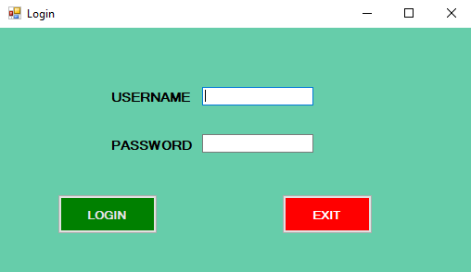

The program is very easy to navigate and the each form up to the main menu do not contain lots of unnecessary text and etc. so the design of the program remains simple.

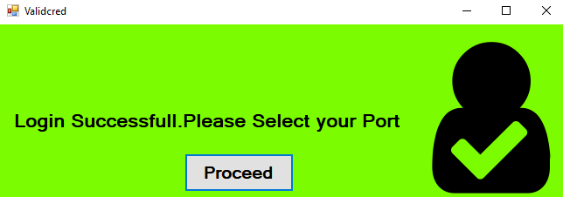

The following screens are displayed depending on the user’s input for the credentials. The text on each form is clearly visible to even those with weak eyesight.

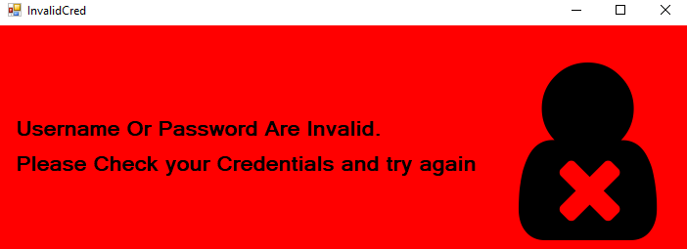

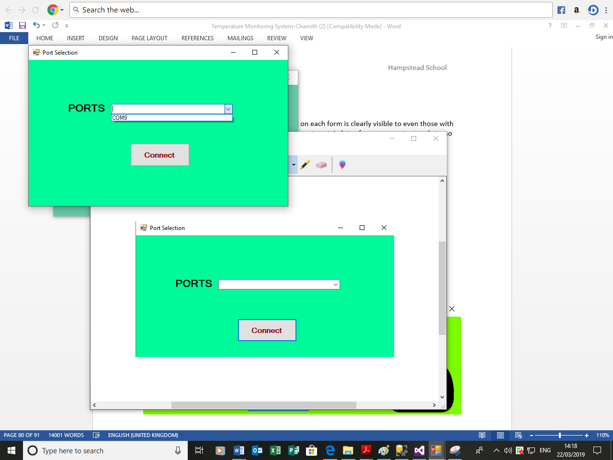

Not at all complex to use because the user simply selects the port and click connect therefore only two actions are required from the user.

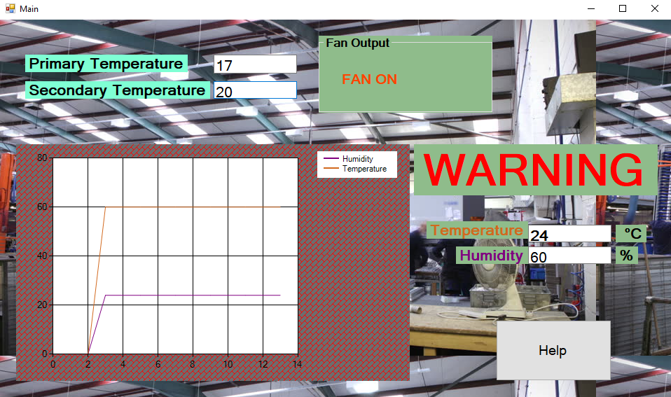

Warning label is made much larger and clearer to ensure that the user do not fail to see it.

Help button is made large and the black writing contrast well with the white to stand out.

All the complicated parts of receiving live readings and generating warnings are done by the program hence all that is required from the user is to carry out the appropriate actions according to the warnings and enter set values.



Values are labelled clearly for the users to see.

Colours green and purple stands out visibly against the white background of the graph.



Instructions help the user when navigating the program. This window is opened with the click of the help button that is located in the main window.

Vital information is highlighted so that users know what response to take if the live temperature exceeds the set values.

## Limitations & Maintenance

The main limitation of this program is that it lacks the capability to control the fan output itself, it warns the user to turn on the fan when the primary temperature is exceeded however it does not have the ability to turn the fan on itself and so it relies on the user. As I have mentioned during the analysis stage, this program is simply used to model a larger system so if this model is applied to a larger system for example a warehouse then it obviously requires better hardware capable of monitoring and controlling temperatures for a large environment.

To improve this software for future uses it could ensure that the users are not only warned of the increasing temperatures but they are automatically controlled as well. My current program will warn the user to turn on the fan; a future update should consist of a system to actually turn the fan or off once the set values for temperature are exceeded.

Program itself requires the use of both software and hardware however it is important that the sensor is setup correctly otherwise it will not be able to receive readings (see page 31).Once setup the program itself is very simple to use however the system can be made more convenient for the user by having the components of the hardware such as the senor and the LED fixed into the board so that the user do not need to spend time setting up the hardware.

I believe that the system itself requires very low maintenance due to the fact that most if not all of the inputs are validated. In terms of software the system is simple to navigate the main form given the users have the correct credentials to gain access and have connected to a valid port containing the hardware.

## Code Listing

SQL



Arduino.

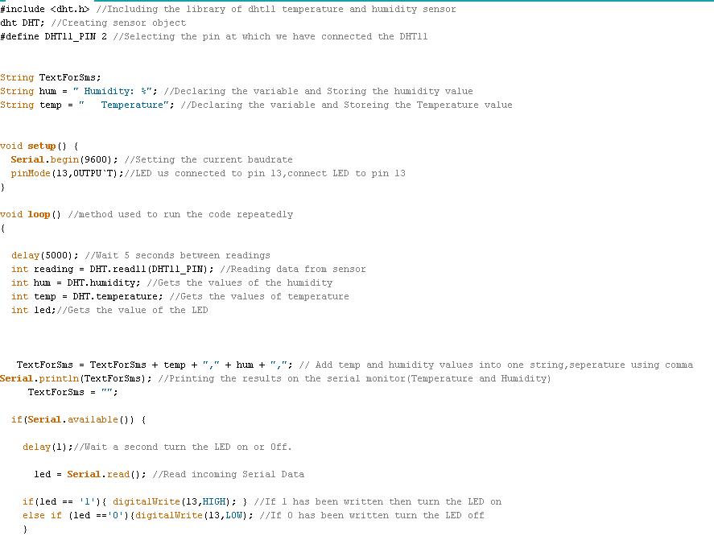

Login Form

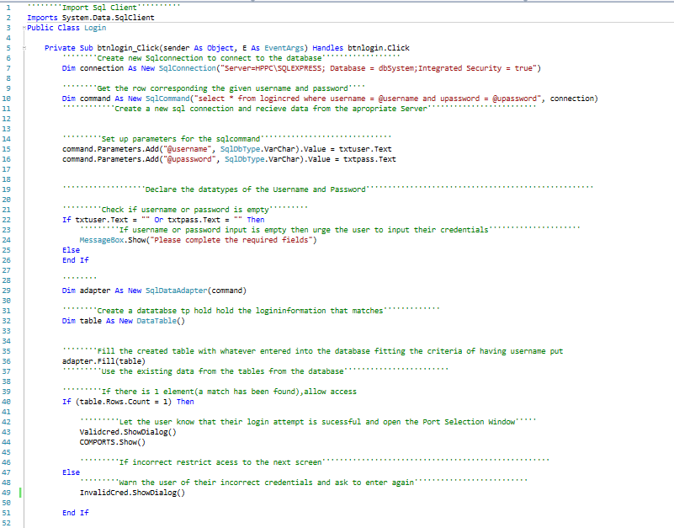

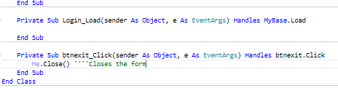

Port Selection

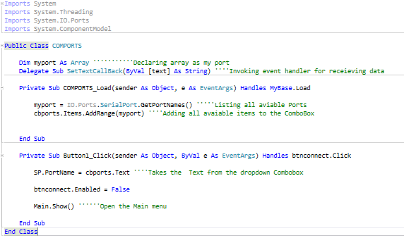

Main

